**iSpace v2 Manual**

Table of Contents

**Part 1 Getting Started** 4

**1.****Introduction** 4

**2.****Login and My home page** 4

**2.1****Logging into iSpace** 4

**2.2****My Home page** 5

**2.3****Overview of a course homepage** 5

**3.****Adding Resources to your Course** 7

**3.1****Entering your course** 7

**3.2****Adding Files** 8

**3.3****Adding Folders** 12

**4.****Adding Activities to Your Course** 14

**5.****Editing your Course Setting** 17

**6.****Managing your Profile** 19

**Part 2 Course Administration** 20

**1.****Adding TAs and co-Teachers** 20

**2.****Groups and Groupings** 22

**2.1****About Groups and Groupings** 22

**2.2****Creating Groups** 23

**2.3****Adding Users to Groups** 25

**2.4****Creating Groupings** 29

**2.5****Selecting grouping in activity** 31

**3.****Backing up a Course** 32

**4.****Import resources and activities from other course** 35

**Part 3 Content & Learning Resources** 38

**1****Adding files for your student to download** 38

**1.1****Adding files** 38

**1.2****Adding folders** 41

**2****Adding  Pages** 43

**3****Link to a website or webpage** 45

**4****Organizing Your Course Resources** 47

**4.1****Name you Topic** 47

**4.2****Rearrange(move) Items** 49

**4.3****Organizing Items within a Section through Labels.** 50

**Part 4 Assessment & Evaluation** 52

**1****Assignment** 52

**1.1****Adding Assignment** 52

**1.2****Configuring Assignment** 53

**1.3****Grading Assignments** 55

**2****Quiz** 61

**2.1****Adding a Quiz** 62

**2.2****Configuring Quiz** 63

**2.3****Adding and organizing Questions** 65

**2.4****Preview Quiz** 71

**2.5****Review and grade attempts** 72

**3****Feedback** 75

**3.1****Adding a Feedback to your Course** 75

**3.2****Configuring Feedback Activity** 76

**3.3****Adding Questions to the Feedback** 78

**3.4****Analyzing and Exporting Feedback Results** 80

**4****Gradebook** 81

**4.1****View and editing grades.** 81

**4.2****Export and import grades.** 83

**Part 1 Getting Started**

1. **Introduction**

iSpace is an e-learning platform, also a Learning Management System (LMS), or Virtual Learning Environment (VLE). It was built from Moodle ([http://moodle.org](http://moodle.org/)), It’s very effective for educators to use iSpace to create online learning courses.

In this part, our main purpose is to give an overview of the most common iSpace functions so that users can get started with iSpace quickly, this part will not cover all iSpace features. If you want to learn details of function, please refer other parts.

1. **Login and My home page**
   1. **Logging into iSpace**
2. Enter [http://ispace.uic.edu.hk](http://ispace.uic.edu.hk/) in your browser.

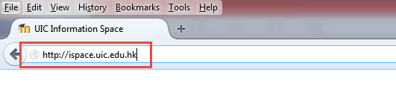

1. Click “Log in” on the top right of your home page.

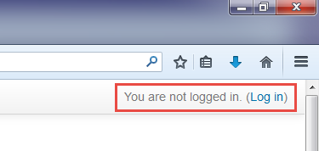

1. Logging into iSpace by using your UIC usernaem and paswword.

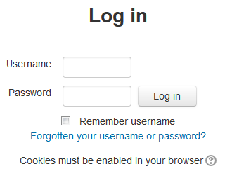

* 1. **My Home page**

The “My home” page will be presented after you login into iSpace, which you can customize to your needs.

My Home page gives you an overview of your course and their upcoming deadlines and recent activity.

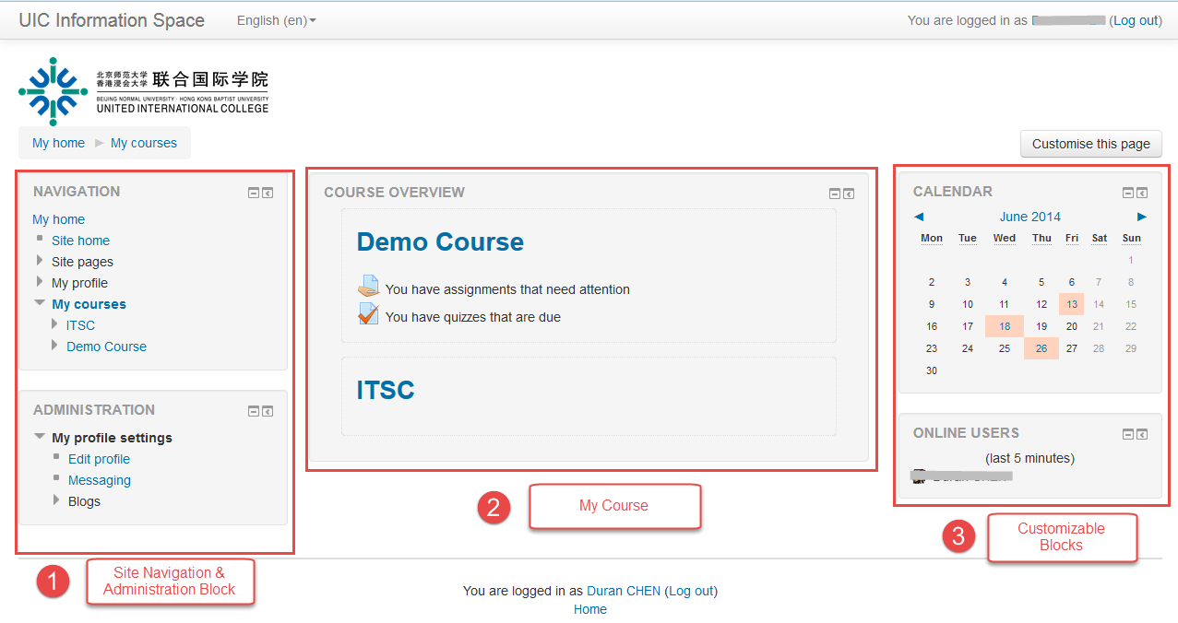

* 1. **Overview of a course homepage**

Clicking the name of a course in the ‘My Home’ page, your course’s main page will be presented as below.

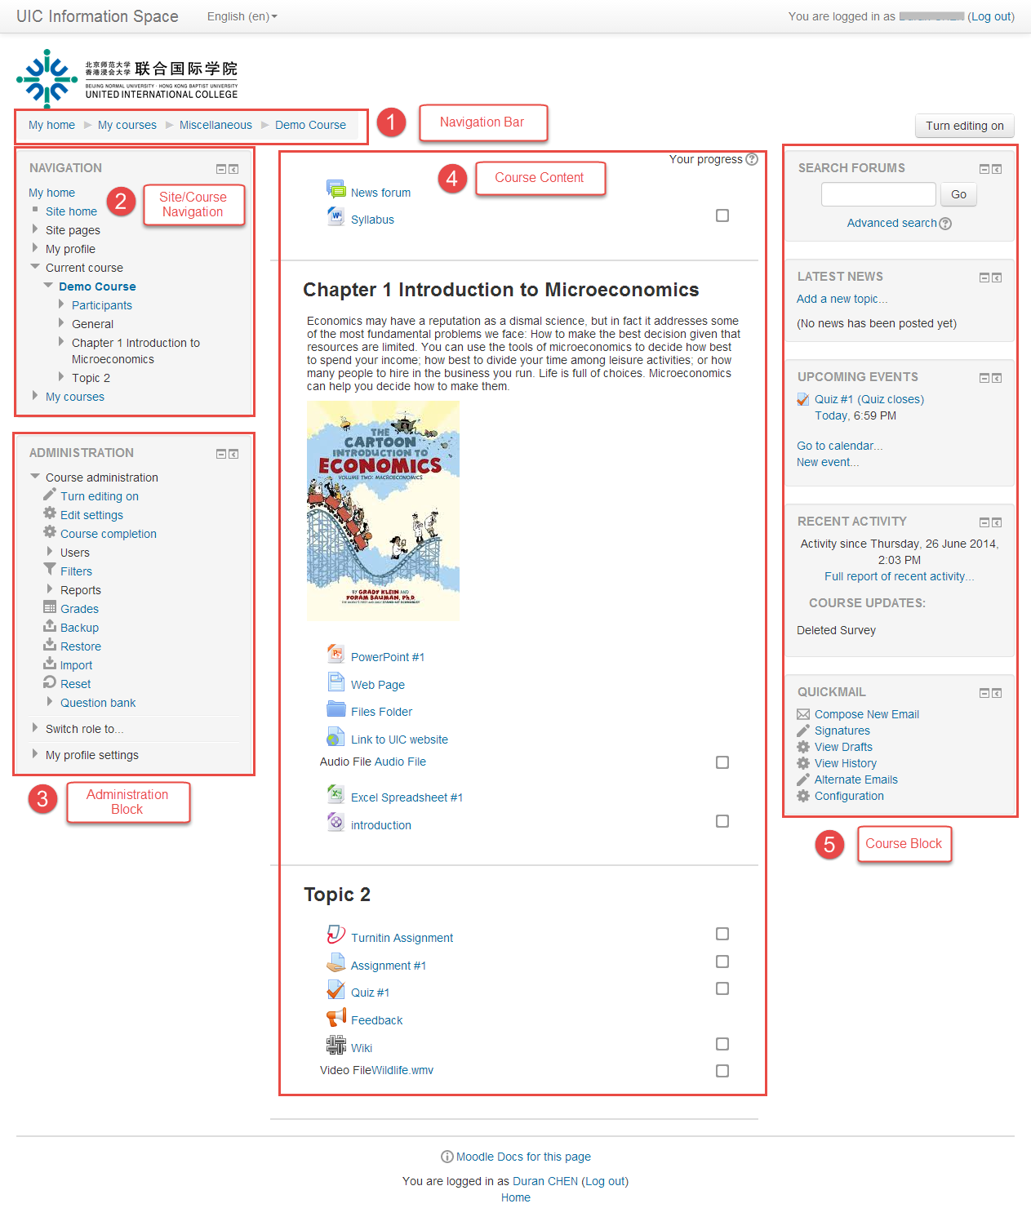

* **Navigation bar**

Each Course has a horizontal navigation bar at the top. It shows where you are. Each item on the bar is a link which allows you to return to where you have been.

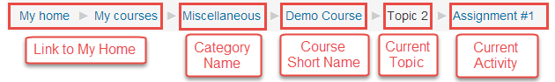

* **Site/Course Navigation Block**

The Navigation Block is on all pages in iSpace. It contains links to navigation around the site.

* **Administration Block**

The options of administration block depend upon your location in iSpace. The options on course homepage usually include course administration, the list of role which you can switch to and your profile settings.

* **Course Content/Topic**

The content of your course is presented here, such as resources and activities. They are split into topics or weekly.

* **Course Blocks**

The Blocks area is a fully customizable area. You can add, delete, and rearrange them. On the course home page, the area usually includes Latest news, Upcoming events, Recent activity etc.

1. **Adding Resources to your Course**
2. **Entering your course**
3. Click the course name on the ‘My Home’ page.

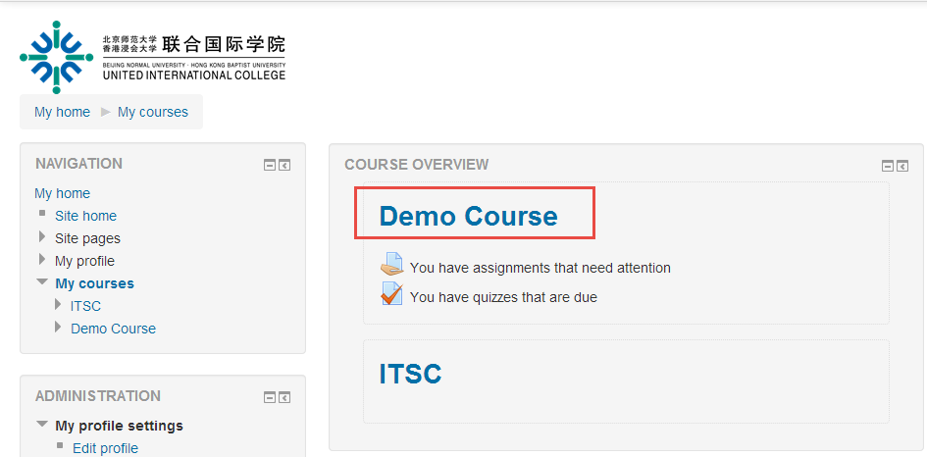

1. Click the “Turn editing on” button to switch course into editing mode.

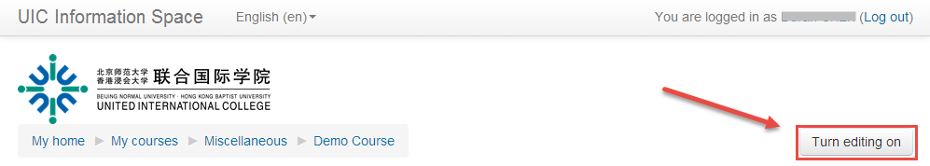

1. **Adding Files**

You can upload a file (Word Document, Excel Spreadsheet, PowerPoint, and PDF) to your course by either dragging it directly to your course page or by uploading it using ‘Add an activity or resource’ dialogue box.

**Option 1 – Drag and Drop**

1. Make sure your course is editing mode, if it is not, please click ‘Turn editing on’ button at the top right of the course page.



1. Drag the file from your computer to the section of the course page where you want the file to be listed. When a dotted box appears, drop the file into the box.

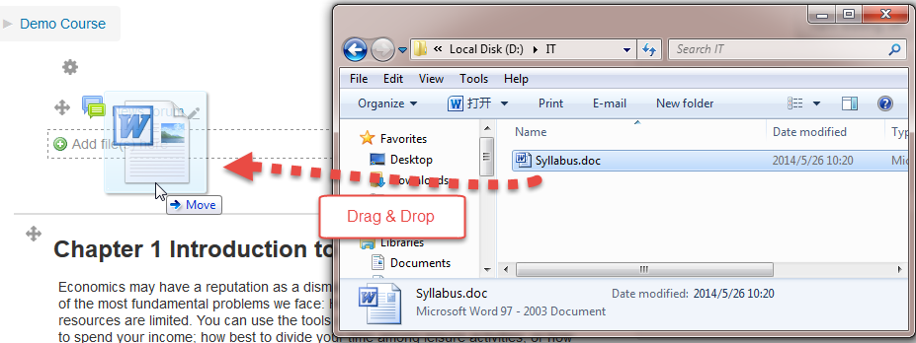

**Option 2 –Adding file by ‘Add an activity or resource’ dialogue box.**

1. Make sure your course is editing mode, if it is not, please click ‘Turn editing on’ button at the top right of the course page.



1. Click “Add an activity or resource” button.

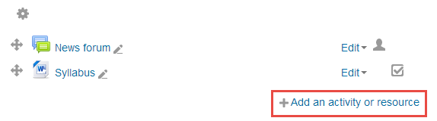

1. Choose Recourse type: File in the pop-up box, then click ‘Add’ button. The settings will be presented.

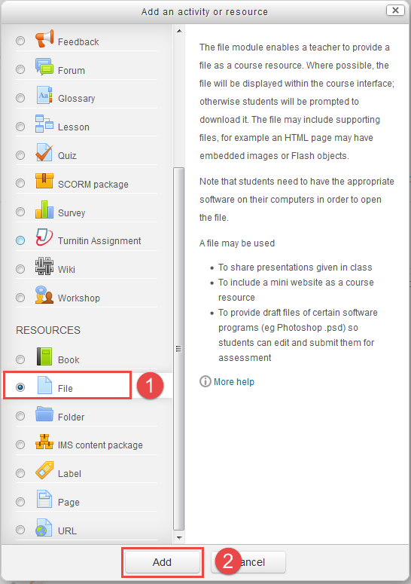

1. Enter the name and description fields.

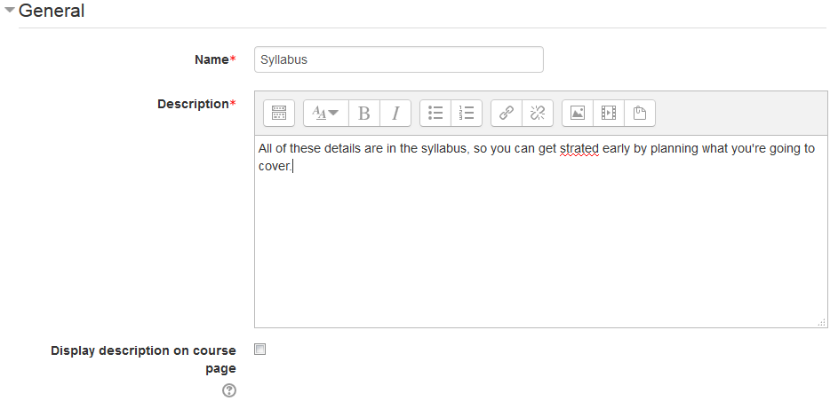

1. On the ‘Content’ area, you can drag the file from your computer and drop it in the marked area (dashed rectangle);

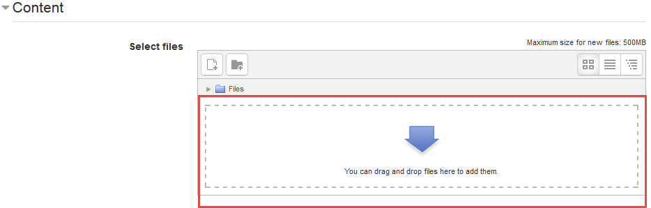

Or click ‘add’ button() to open the file pick, and choose file from your computer, then click ‘upload this file’ button.

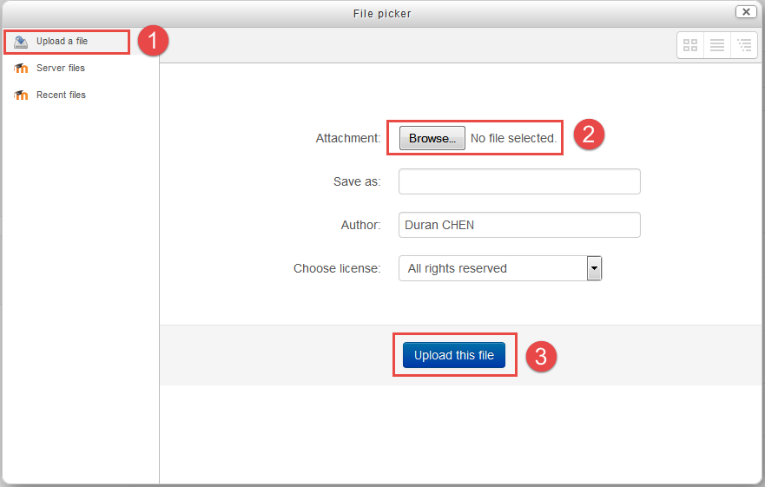

1. Click ‘Save and return to course’ or ‘Save and display’button.

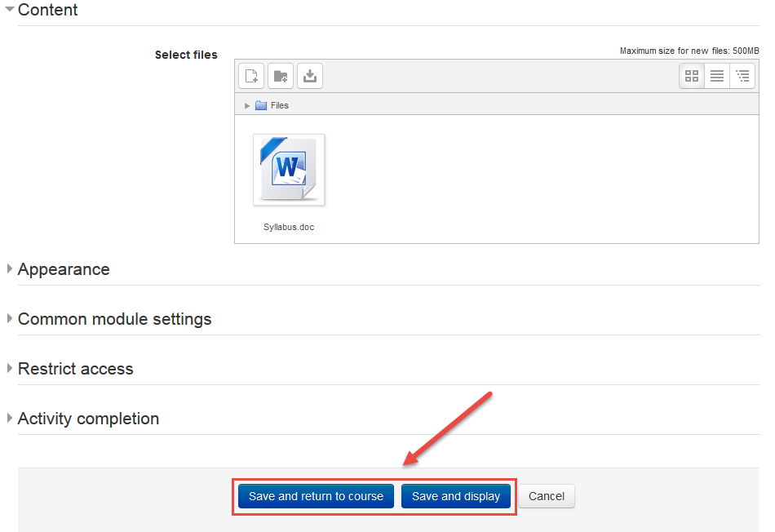

1. **Adding Folders**

When you want to make several files available to students in your course, a folder will be a good choice.

You can upload a folder to your course by uploading it using ‘Add an activity or resource’ dialogue box.

1. Click ‘Turn editing on’ at the top right of the course home page.



1. Click “Add an activity or resource” button.



1. Select ‘Folder’ in the pop-up windows, and then click ‘Add’ button. The settings page will be presented.

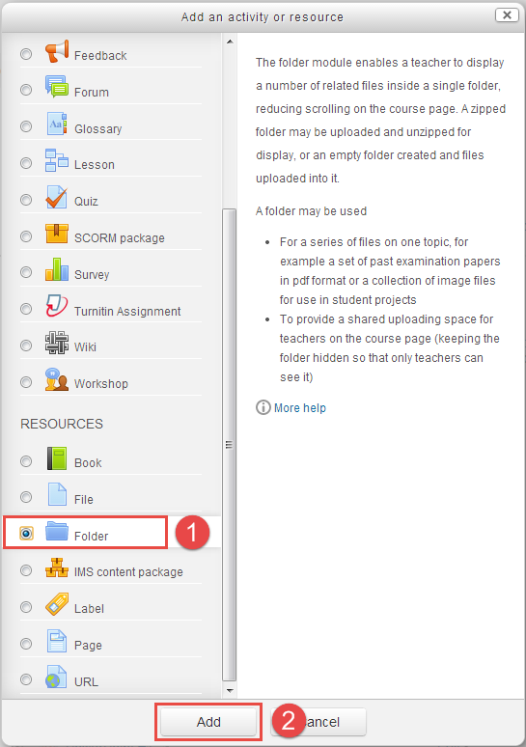

1. Complete the name and description fields, same as ‘add file settings’.
2. On ‘Content’ area, you can do one of the following to add a file, same as ‘add file settings’:
3. Drag files from your computer and drop them in the marked area (dashed rectangle).
4. Click ‘add’ button() to open the file pick, and choose file from your computer, then click ‘upload this file’ button.



1. Click ‘Save and return to course’ button.
2. **Adding Activities to Your Course**

Activities are typically used as a way for students to engage with the content and also for assessment purposes. These include discussion forums, assignments, quizzes, etc.

1. Click ‘Turn editing on’ at the top right of the course home page.



1. Click “Add an activity or resource” button.



1. Select an activity which you want to use in the pop-up windows, and then click ‘Add’ button. The activity settings page will be presented.

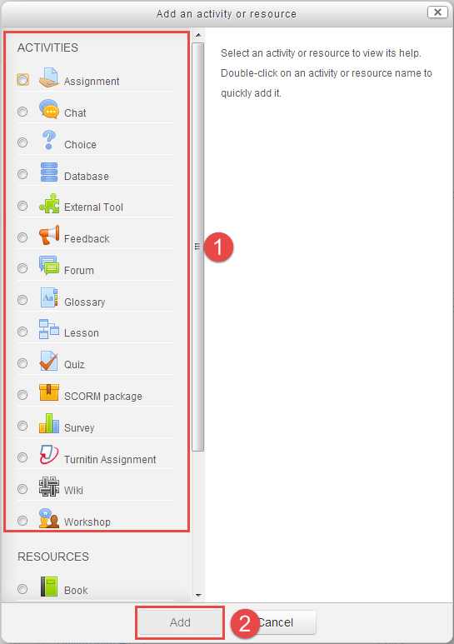

**A brief introduction of all popular activities in iSpace is listed below.**

* + - Assignment ()



The assignment activity module enables a teacher to communicate tasks, collect work and provide grades and feedback.

Students can submit any digital content (files), such as. Word-processed documents, Spreadsheets, Images, Audio and Video clips, online text, Offline activity

* + - Quiz（）



The quiz activity enables a teacher to create quizzes comprising questions of various types, including multiple choice, matching, short-answer and numerical.

Quizzes may be used

* As course exams
* As mini tests for reading assignments or at the end of a topic
* As exam practice using questions from past exams
  + - Feedback ()



The feedback activity module enables a teacher to create a custom survey for collecting feedback from participants using a variety of question types including multiple choices, yes/no or text input.

Feedback activities may be used:

* For course evaluations, helping improve the content for later participants
* To enable participants to sign up for course modules, events etc.
* For guest surveys of course choices, school policies etc.
* For anti-bullying surveys in which students can report incidents anonymously.
  + - Chat ()



The chat activity module enables participants to have text-based, real-time synchronous discussions. Chats are especially useful when the group chatting is not able to meet face-to-face.

* + - Choice ()



The choice activity module enables a teacher to ask a single question and offer a selection of possible responses.

* As a quick poll to stimulate thinking about a topic
* To quickly test students' understanding
* To facilitate student decision-making, for example allowing students to vote on a direction for the course
  + - Forum ()



The forum activity module enables participants to have asynchronous discussions. Teacher can allow files to be attached to forum posts.

Forums have many uses:

* A social space for students to get to know each other
* For course announcements (using a news forum with forced subscription)
* For discussing course content or reading materials
* For continuing online an issue raised previously in a face-to-face session
* For teacher-only discussions (using a hidden forum)
* A help centre where tutors and students can give advice
* A one-on-one support area for private student-teacher communications (using a forum with separate groups and with one student per group)
* For extension activities, for example ‘brain teasers’ for students to ponder and suggest solutions to

1. **Editing your Course Setting**

Before making your course available to students, it is important to configure a few settings.

1. Click ‘Edit settings’ Link in the Administration block, then the settings page will be presented.

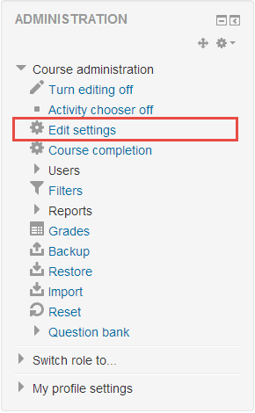

1. The following configurations are critical to the initial set up of your course:

**General**

* Course Start date

**Course Format**

* Format
* Number of sections
* Course layout

**Groups**

* Group mode

There are four **Course Formats** you can choose:

* **Single activity format** - For displaying a single activity or resource (such as a Quiz or SCORM package) on the course page
* **Social format** - A forum is displayed on the course page
* **Topics format** - The course page is organized into topic sections
* **Weekly format** - The course page is organized into weekly sections, with the first week starting on the course start date

Refer to the figure below to locate these specific settings on the ‘**Edit course settings’** page.

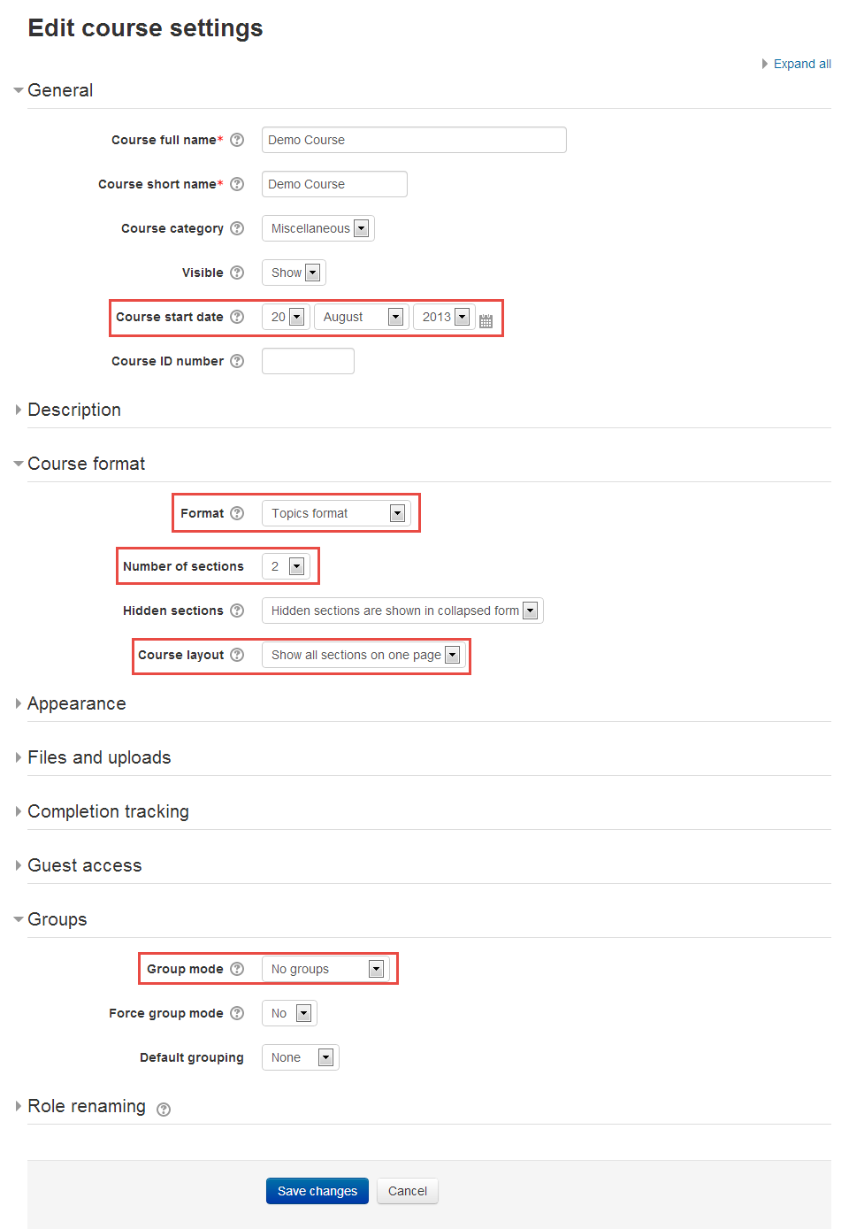

1. **Managing your Profile**

Profile is important, it can let other teachers and students know who you are and what your background and interests are.

1. Once you have logged into iSpace, you can access your profile from the administration block as below.

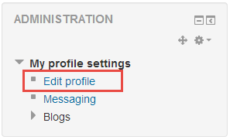

1. On the screen below, you may change your profile if desired, but remember that it will be visible to everyone on the site, please protect your privacy carefully.

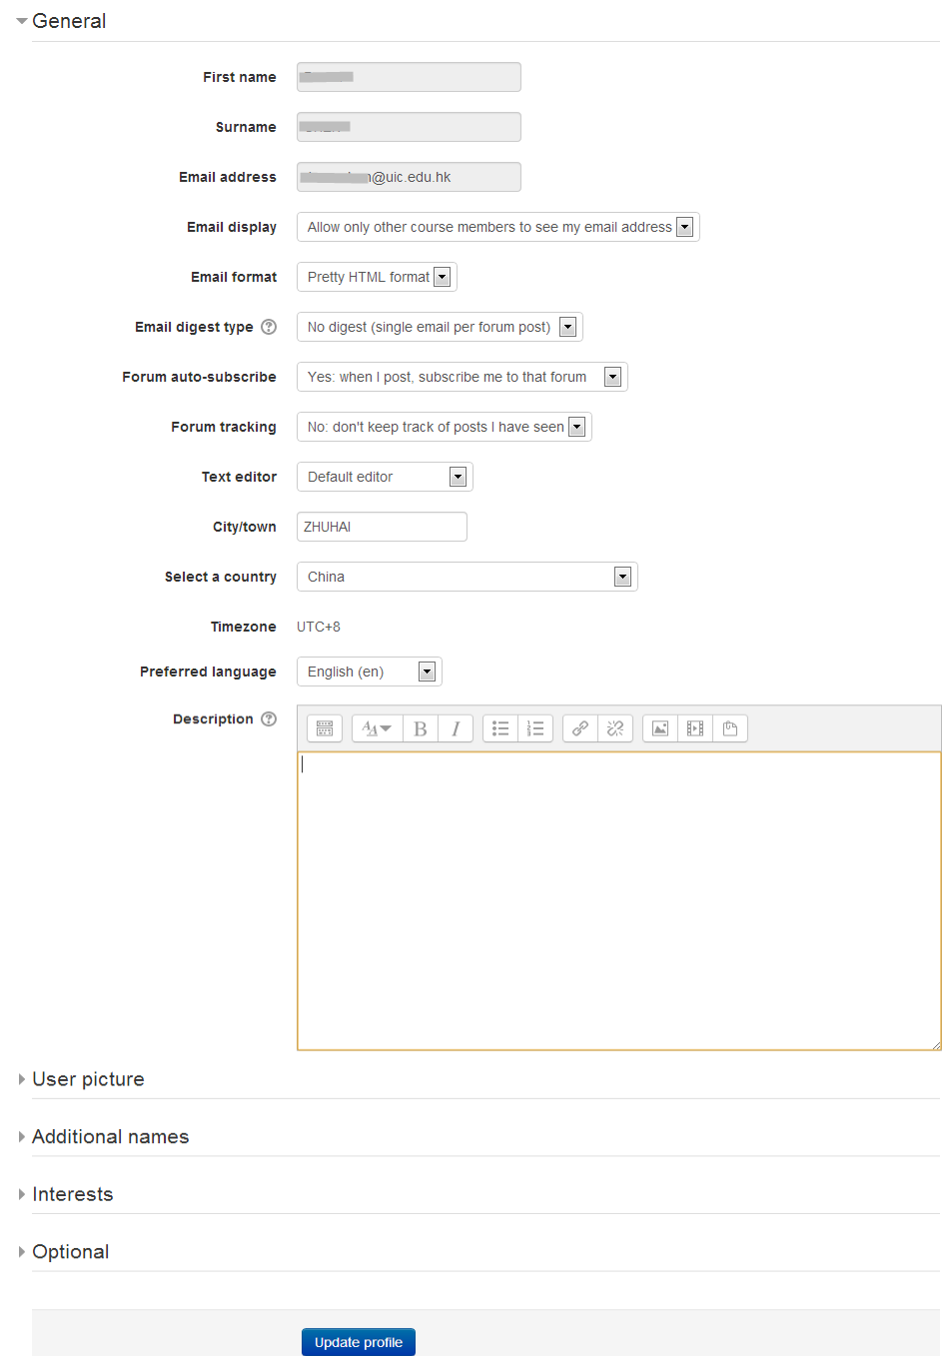

**Part 2 Course Administration**

1. **Adding TAs and co-Teachers**

As a course teacher, you are automatically assigned the role of Teacher in your course. But you may want to add TAs, co-teachers or colleagues to your course.

1. Click the ‘Users’ in the ‘Administration block’ to expand the menu, and then click ‘Enrolled users’. A list of current users, if any, will be display.

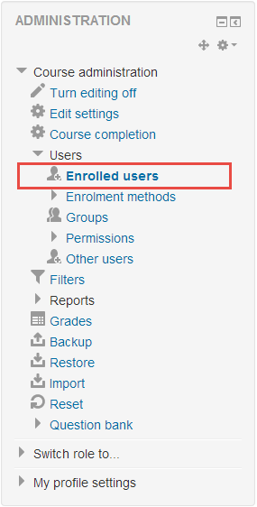

1. The enrolled users list will be shown as below, and then click ‘Enrol users’ button on the top right to add a Teaching Assistant to your course.

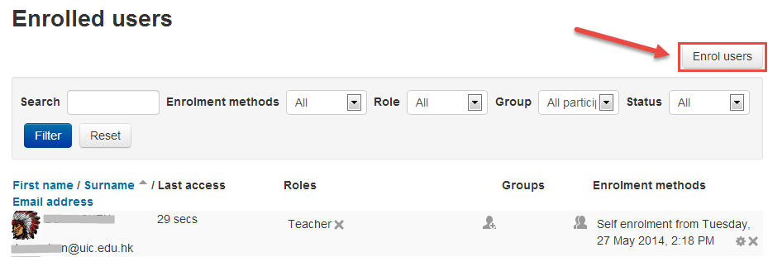

1. Follow these steps below to enroll a user as ‘Teaching Assistant’ role in your course.
2. Click the ‘Assign roles’ drop-down list, select the ‘Teaching Assistant’ role.
3. In the search field, enter the TA’s email or name, then click ‘Search’ button.
4. Click the ‘Enrol’ button in the right of the user’s name to add them to your course.
5. Repeat step 2 and step 3 to add more teaching assistants.
6. Click the ‘Finish enrolling users’ button to add them to your course.

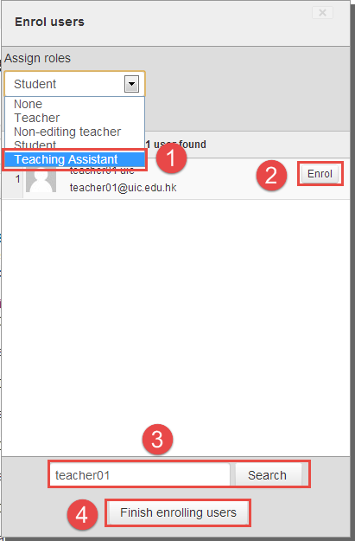

1. **Groups and Groupings**
   1. **About Groups and Groupings**

* **Groups**

Enrolled Users can be divided into groups within the course. Once groups have been created in a course, then they may need to be assign into grouping (see the ‘grouping’ part), grouping can be set for particular course activities, such as Forums and Assignments.

* **Groupings**

If you want to make an activity (such as an assignment or a quiz) visible to only one set of users within a course, you need first to put the users into a group and then put them into a grouping. A single grouping can house one group or several groups.

**Why uses** groups **and groupings?**

* You are a teacher in a course where you have several classes and you want to filter your activities and gradebook so you only see one class at a time.
* You are a teacher sharing a course with other teachers and you want to filter your activities and gradebook so you don’t see the students from your colleagues’ classes.
* You want to allocate a particular activity or resource to just one class or set of users and you don’t want others to see it. See Groupings

*NOTE: an activity cannot be linked to group. Only groupings can linked to activity*.

* 1. **Creating Groups**

Follow the steps below to create groups in a course.

1. Click the ‘Users’ link to expand the menu in the Administration block, and then click the ‘Groups’ link.

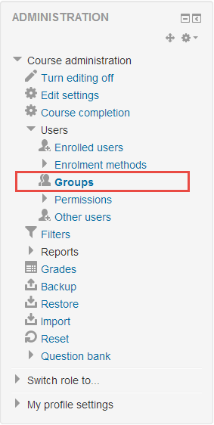

1. Click the ‘Create group’ button to create a new group.

*The* Groups *tab appears containing two columns. The left column displays group names (initially empty). The right column will display a list of the assigned group members.*

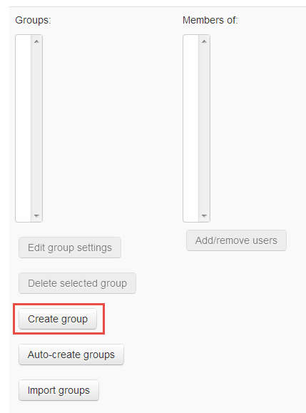

1. Please follow these steps to configure the options for group,
2. Enter a required name in the ‘Group name’ filed.
3. Enter an ‘Enrolment key’ if you require users with this group enrolment key to be assigned to this group.

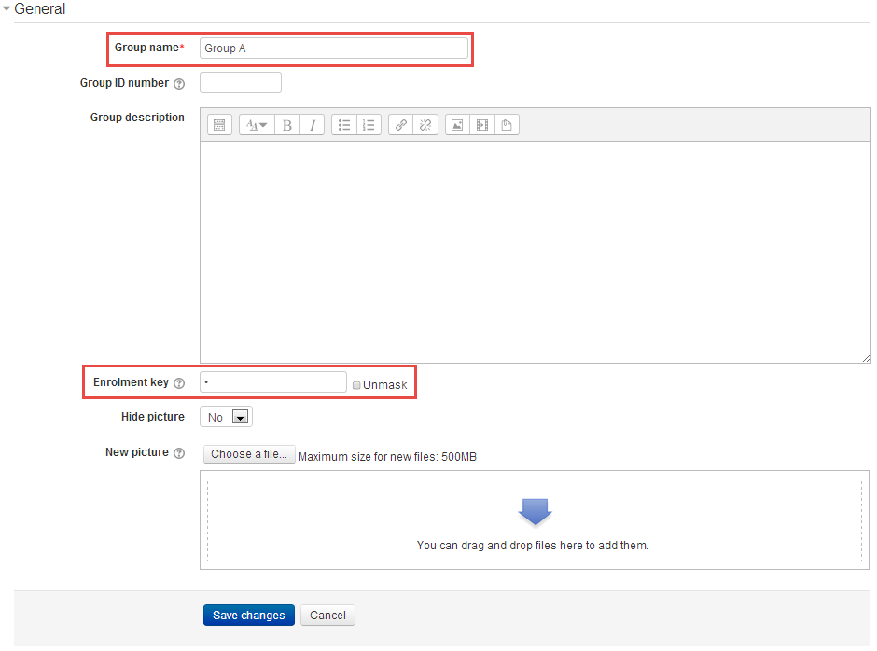

*Note: An enrolment key for the course must be specified in the self-enrolment settings as well as group enrolment keys in the group settings. When a user finishes the enrolment process with group enrolment key, not the self-enrolment key, they will automatically be assigned to the group.*

* 1. **Adding Users to Groups**

**Option 1- The total number of enrolled users is below 100**

Use this option when the total number of users enrolled in the course is below 100 and/or when you want to search for the user(s) to add into groups.

Follow these steps to add users to Group.

1. Click the ‘Users’ menu in the Administration block to expand the sub-menu, and then click the ‘Groups’ link.



1. Click the group name to choose group on the left, and then click the ‘Add/remove users’ button in the Members of Group Colum on the right.

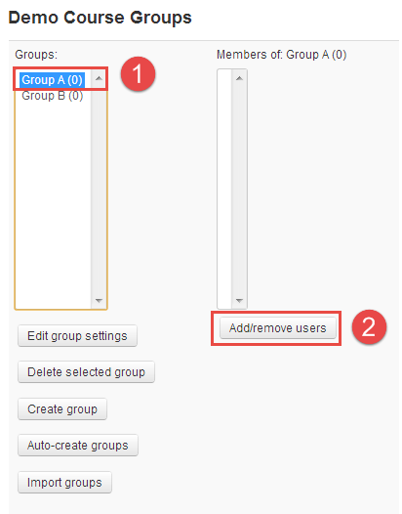

1. Click the name of student to choose students in the ‘Potential members’ column on the right (You can select more than one user by Ctrl + Click), and then click ‘Add’ button to add the selected student(s) to the “Group members” list.

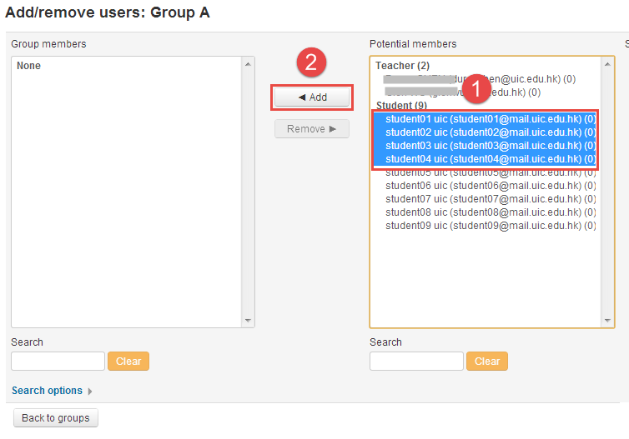

*To remove user(s) from the Group members list, just click the user(s) and then click ‘Remove’ button.*

1. Click ‘Back to groups’ when you have completed adding users to group.

**Option 2 - More than 100 users in your course**

When there are more than 100 users in your course, iSpace will display too many users (xxx) to show in the Potential members list. In this case, you will need to use the search function to add individual users to the group. Alternatively, you can assign users to a group by selecting from the list of Enrolled users.

1. Click the ‘Users’ in the ‘Administration block’ to expand the menu, and then click ‘Enrolled users’. A list of current users, if any, will be display.

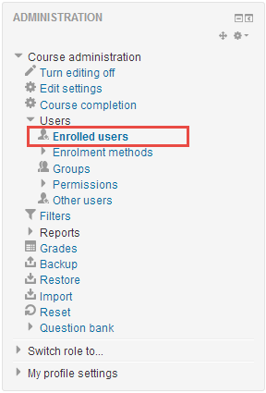

1. Click the ‘’ button within the ‘Groups’ column to add the user to group.

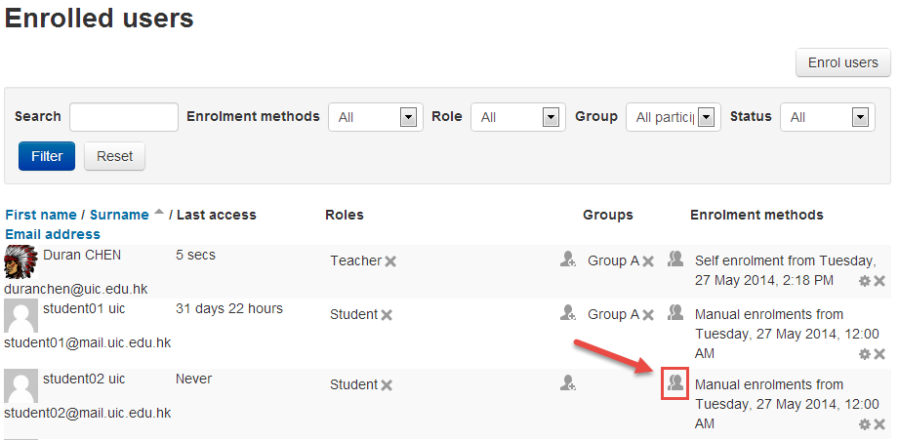

1. Select the group from the ‘Add user into group’ drop-down menu, then click the ‘Save’ button to add the user into the group.

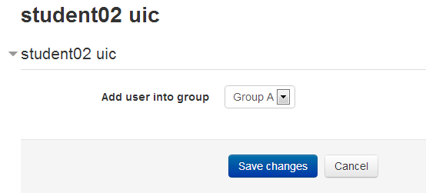

* 1. **Creating Groupings**

1. Click the ‘Users’ link to expand the menu in the Administration block, and then click the ‘Groups’ link.



1. Click the ‘Groupings’ tab to create a new grouping.

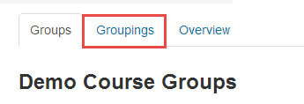

1. Click the ‘Create grouping’ button to start creating grouping.

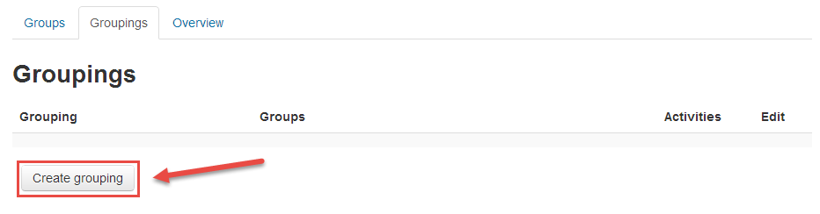

1. Type a name in the ‘Grouping name’ field, then click the ‘Save changes’ button.

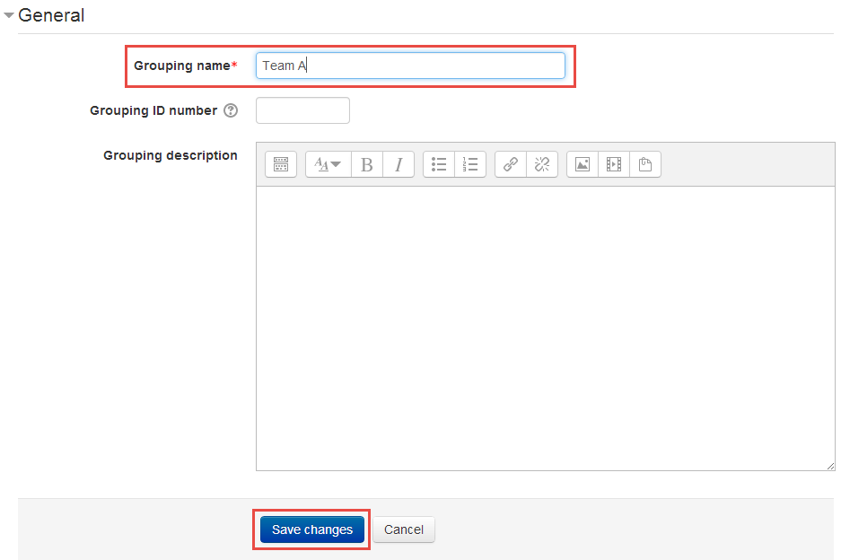

1. Click the Group icon() in the Edit column to add groups to the grouping.

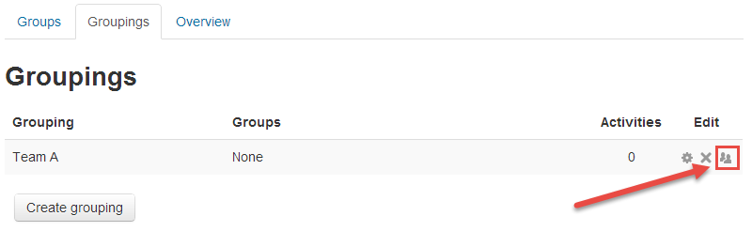

1. Click the group name in the Potential members column, then click the Add button. Repeat these steps to add more groups to the grouping.

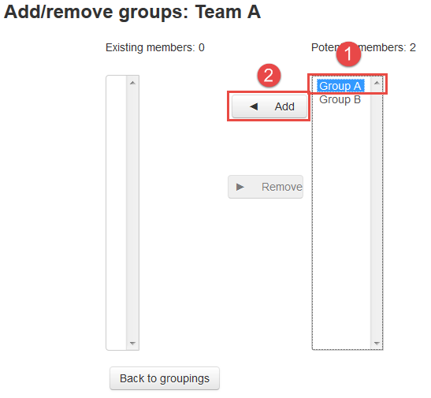

*To remove a group from the grouping, click the group name in the Existing members column then click the Remove button.*

* 1. **Selecting grouping in activity**

To use a particular grouping in an activity，please follow these steps below.

In ‘edit settings’ page of an activity, click the ‘Common module settings’ to expand the settings.

1. Make the group mode to separate or visible groups.
2. Select the grouping from the grouping dropdown menu.

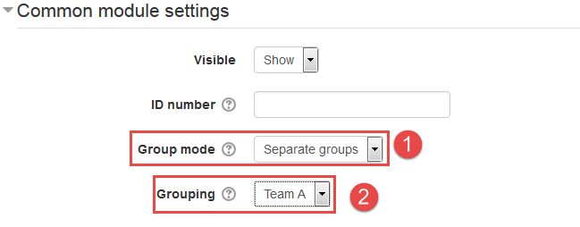

*Note: Students will only see the activities they have been assigned to. Teachers will see the name of the grouping in brackets after the activity name on the course page.*

1. **Backing up a Course**

For safety reason, we recommend you maintain copies of your courses on your drive.

Follow these steps to back up your course.

1. Click the ‘Backup’ in the ‘Administration block’ on the left side of your main course page.

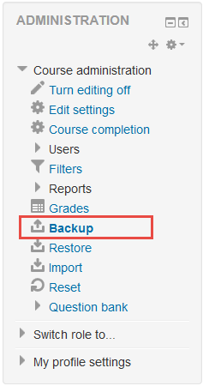

1. On the ‘Initial settings’ page, Select activities, blocks, filters and other items as required then click the ‘Next’ button.

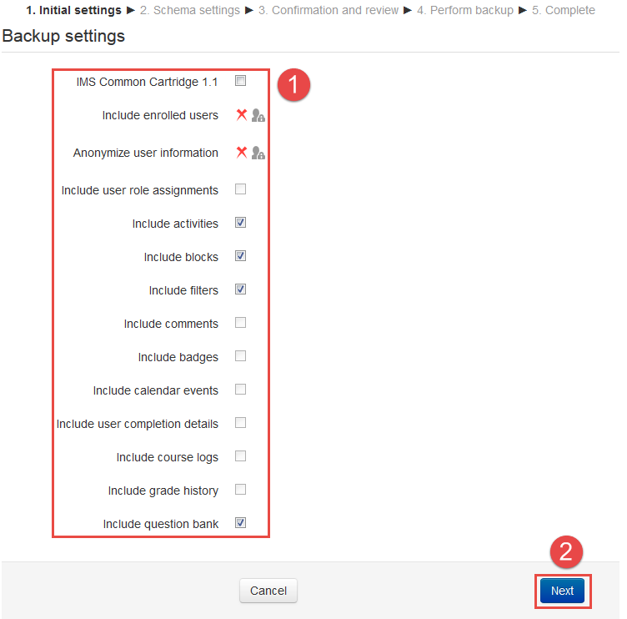

1. On the ‘Schema settings’ page, Select/deselect specific items to include in backup, then click the ‘Next’ button on the right bottom.

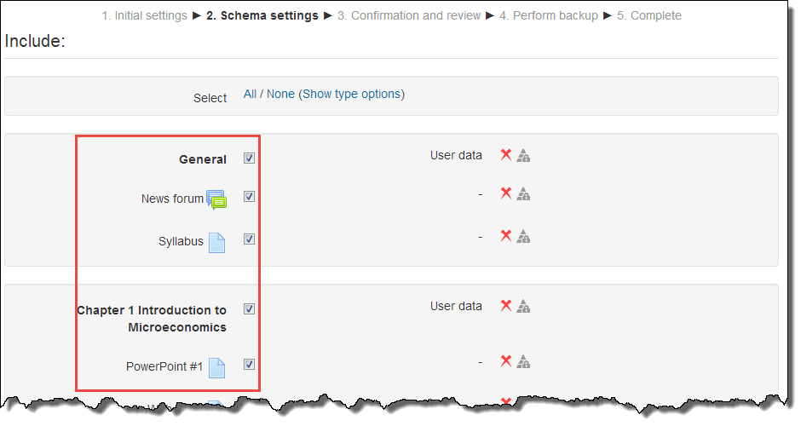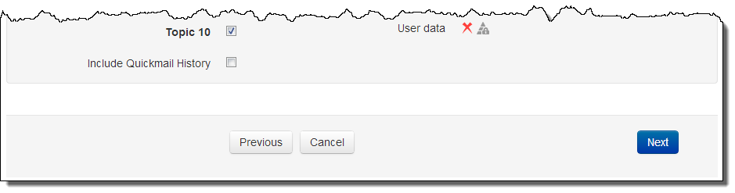

*Note: If desired, select specific types of activity to be backed up by clicking the link 'Show type options'.*

1. On the ‘Confirmation and review’ page, you may edit the ‘Filename’ to recognize easily, such as the course code and backup date. Check that everything is as required, and then click the ‘Perform backup’ button.

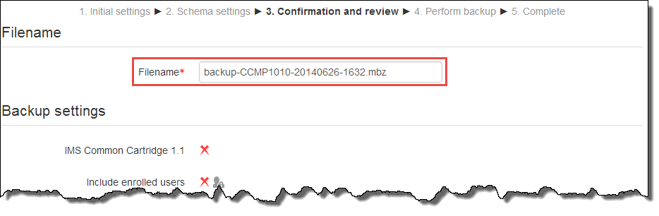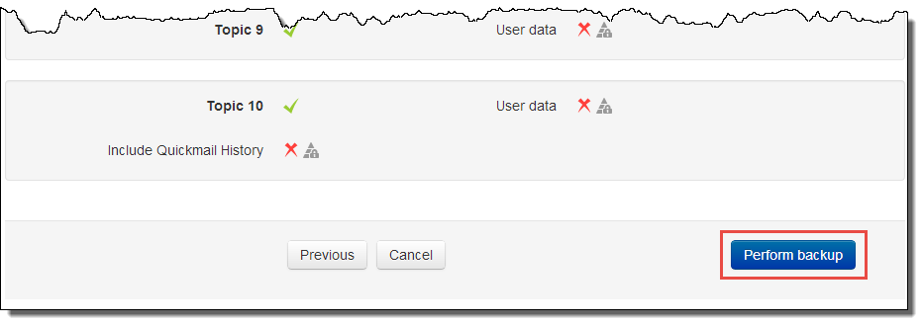

1. On the ‘Perform backup’ page, it may take a couple of minutes to perform backup. Once begun, do not click any button or links until the ‘Complete’ page appears.

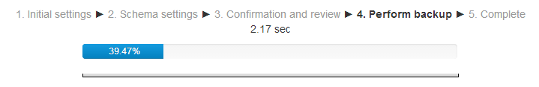

1. On the ‘Complete’ page, click the ‘Continue’ button to finish the backup process.

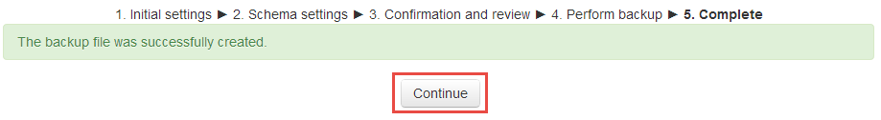

1. Click ‘Download’ to save the backup to your computer.

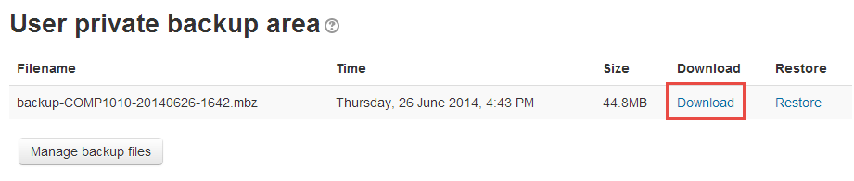

*Note: The backup of the course is an .mbz file, this file type is only for iSpace (Moodle), and it cannot be open by other programs.*

1. **Import resources and activities from other course**

Course resources and activities may be imported from other course which the user is a ‘Teacher’ role in. this can let teacher re-use same resources and activities rather than re-creating them.

Importing course resources and activities is similar to a backup and restore course process.

Follow these steps to import resources and activities

1. Click the ‘Import’ in the ‘Administration block’.

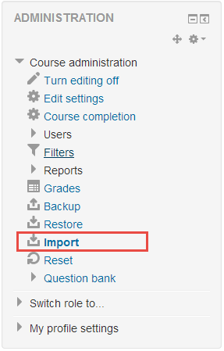

1. Select the course you want to import from , and click the ‘Continue’ button.

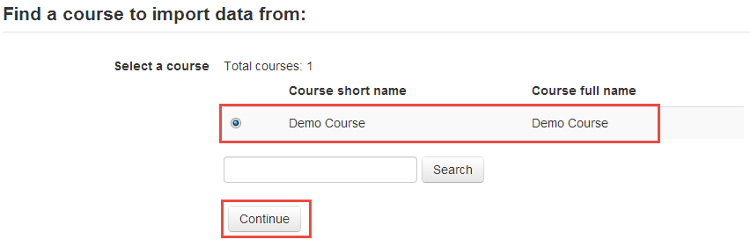

1. On the ‘Initial settings’ page, Select/deselect activities, blocks, filters and other items as required then click the ‘Next’ button.

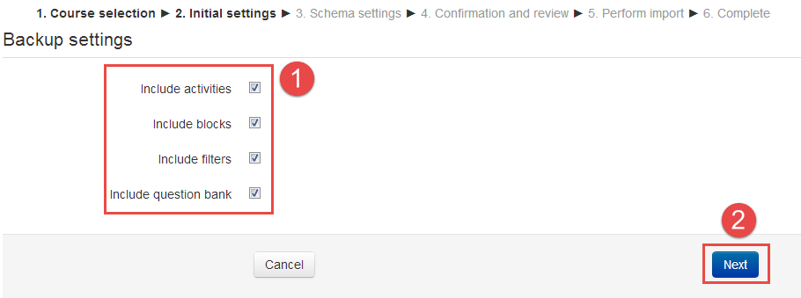

1. On the ‘Schema setting’ page, Select/deselect the specified items you wish to include in the import, and click the ‘Next’ button.

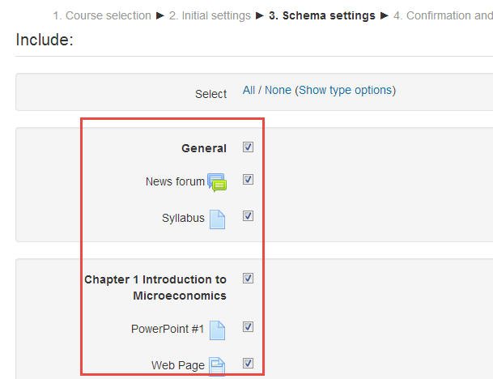

1. On the ‘Confirmation and review’ page, check that everything is as required, and then click the ‘Perform import’ button.

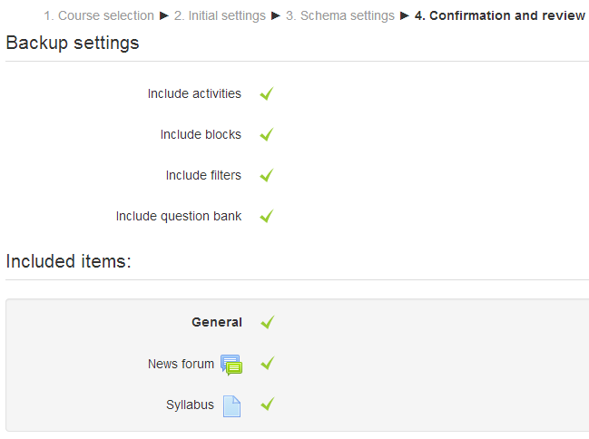

1. Finally, Import complete, Click ‘continue’ button to return to the course.

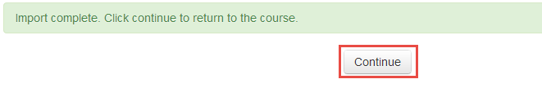

**Part 3 Content & Learning Resources**

1. **Adding files for your student to download**
   1. **Adding files**

You can upload a file to your course by either dragging it directly to your course page or by uploading it using ‘Add an activity or resource’ dialogue box.

**Option 1 – Drag and Drop**

1. Make sure your course is editing mode, if it is not, please click ‘Turn editing on’ button at the top right of the course page.



1. Drag the file from your computer to the section of the course page where you want the file to be listed. When a dotted box appears, drop the file into the box.



**Option 2 –Adding file by ‘Add an activity or resource’ dialogue box.**

1. Make sure your course is editing mode, if it is not, please click ‘Turn editing on’ button at the top right of the course page.



1. Click “Add an activity or resource” button.



1. Choose Recourse type: File in the pop-up box, then click ‘Add’ button. The settings will be presented.



1. Enter the name and description fields.



1. On ‘Content’ area, you can drag the file from your computer and drop it in the marked area (dashed rectangle);



1. Click ‘add’ button() to open the file pick, and choose file from your computer, then click ‘upload this file’ button.



1. Click ‘Save and return to course’ button.



* 1. **Adding folders**

When you want to make several files available to students in your course, a folder will be a good choice.

You can upload a folder to your course by uploading it using ‘Add an activity or resource’ dialogue box. It’s similar to add files to your course.

*NOTE: Teachers are encouraged to structure their course using ‘single file’ resources and appropriately* titled *‘sections’. Because putting teaching materials in folders, students are not notified of any recent additions to folders.*

1. Click ‘Turn editing on’ at the top right of the course home page.



1. Click “Add an activity or resource” button.



1. Select ‘Folder’ in the pop-up windows, and then click ‘Add’ button. The settings page will be presented.



1. Complete the name and description fields, same as ‘add file settings’.
2. On ‘Content’ area, you can drag files from your computer and drop them in the marked area (dashed rectangle).
3. Click ‘add’ button() to open the file pick, and choose file from your computer, then click ‘upload this file’ button.



1. Click ‘Save and return to course’ button.
2. **Adding  Pages**

You can easily add multimedia content, such as text, links, videos, images, to a page. The page is accessible from any browser, include Mobile devices.

Follow these steps to add a Course Page to your course.

1. Click the ‘Turn editing on’ button on the top right of the course main page.



1. Click ‘Add an activity or resource’ link in the section of your course where you wish to add a web page.



1. Select ‘Page’ in the pop-up windows within the Resources part, and then click ‘Add’ button.

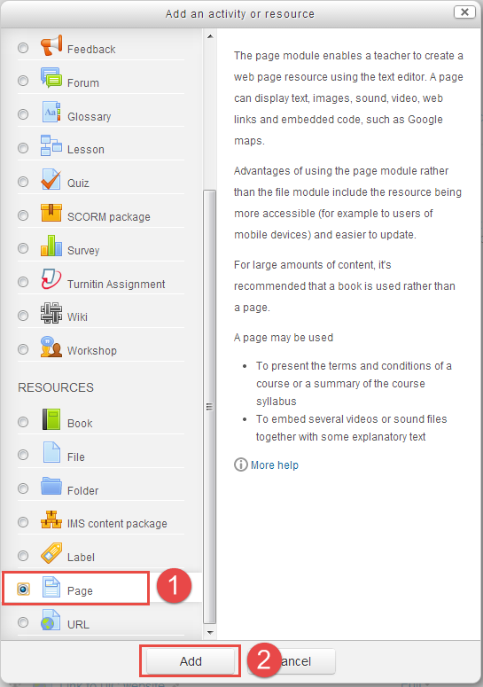

1. Please follow these steps to configure the page settings.
2. Enter the page name which will appear as link in the course main page.
3. Add a description of your page to briefly explain the content or subject of the page.
4. Enter page content in ‘Page content’ text editor.

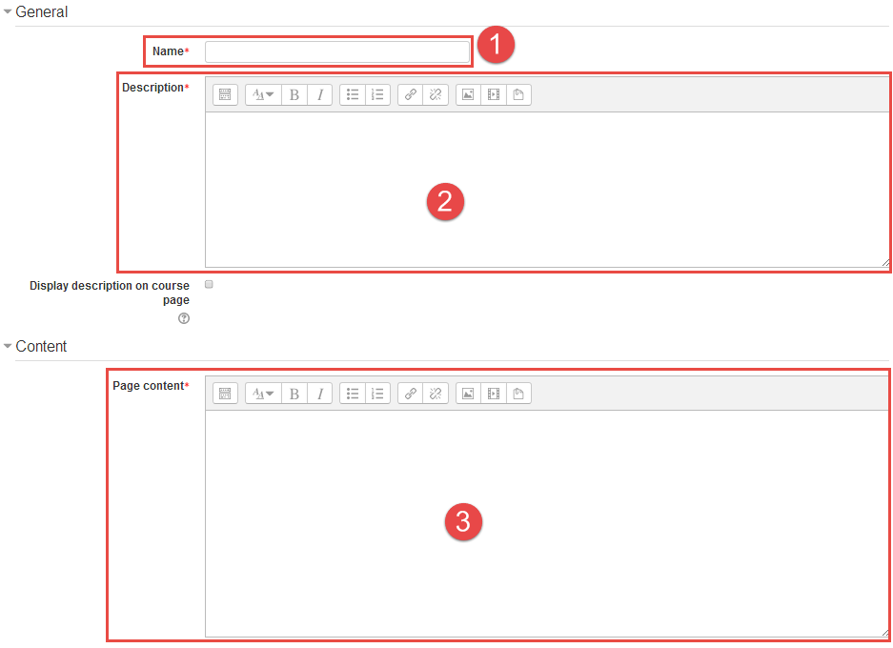

1. Click ‘Save and display’ to view this page.

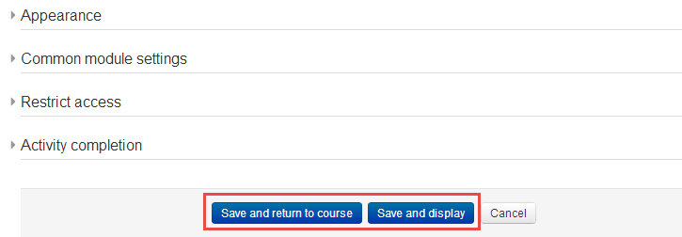

1. **Link to a website or webpage**

To enrich your course, you may want to provide related Web sites to your students, the website link can be added to the section of your course main page.

Follow these steps to add a Course Page to your course.

1. Click the ‘Turn editing on’ button on the top right of the course main page.



1. Click ‘Add an activity or resource’ link in the section of your course where you wish to add a URL.



1. Select ‘URL’ in the pop-up windows within the Resources part, and then click ‘Add’ button.

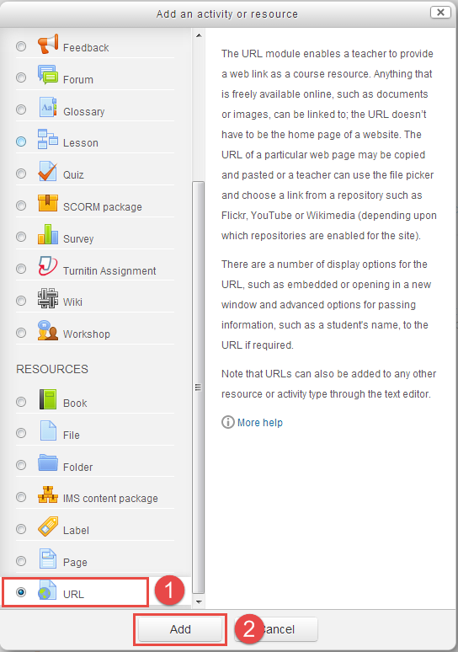

1. Please follow these steps to configure the URL settings.
2. Enter the Website or Webpage name which will appear as link to visit the website or webpage in the course main page.
3. Add a description of the Website or Webpage to briefly describe the content of this website or webpage.
4. In the External URL field, enter the URL you wish to add, for example: [http://www.uic.edu.hk](http://www.uic.edu.hk/).

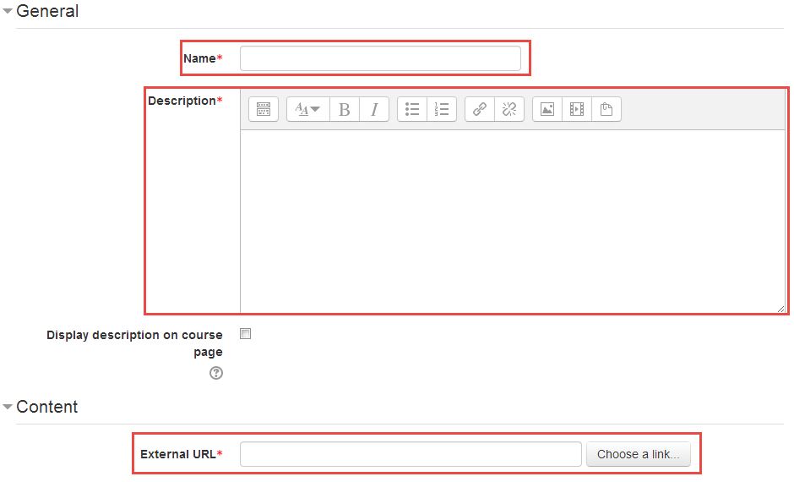

1. Click ‘Save and display’ button to view the URL.

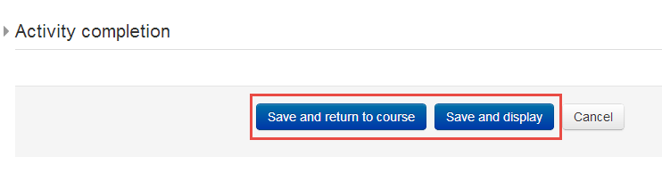

1. **Organizing Your Course Resources**

Topics and Labels are the main tools for organizing a course.

* 1. **Name you Topic**

When you use the ‘Topics format’ in your course, every section will have a default topic name, such as ‘Topic 1’. You might want to name your topics as your real topic name, like ‘Chapter 1 Introduction to Microeconomics’.

Follow these steps to name your topics and add a description to them.

1. Click the ‘Turn editing on’ button on the top right of the course main page.



1. Click the Edit button () under the default topic

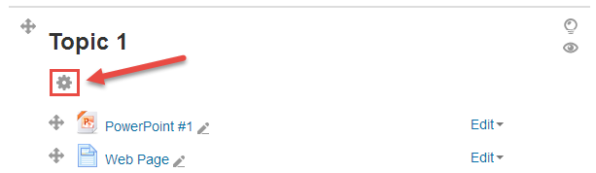

1. Please follow these steps to edit Section name and Summary.
2. Uncheck the checkbox for ‘Use default section name’, and then edit the Section name as you need.
3. If you enter Summary, the summary will be display under the section name.

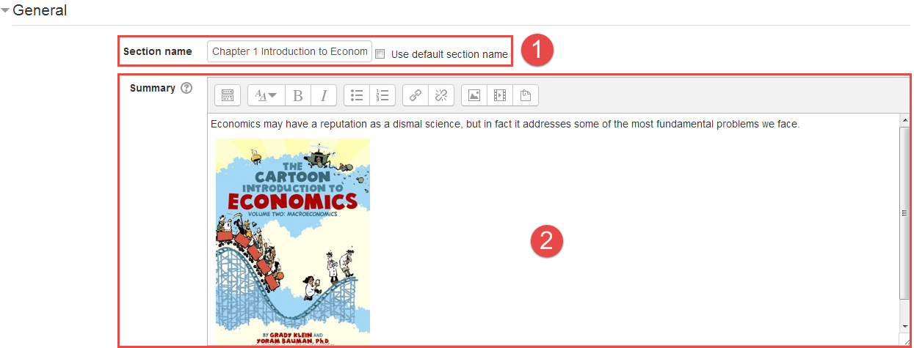

1. Click ‘Save changes’ to save your work, you will be returned to the course main page. The Topic’s name and summary are presented.

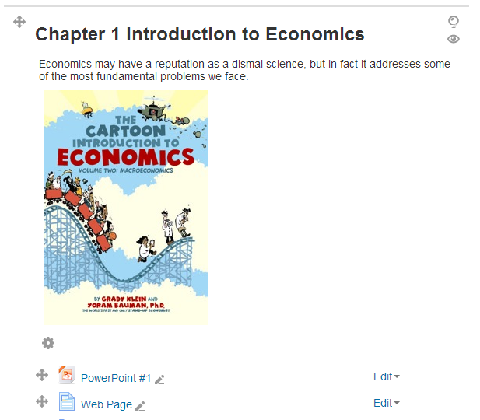

* 1. **Rearrange(move) Items**

iSpace allows you to easily rearrange items (Resources and Activities). So don’t worry about putting them in the right place when you are adding them. You can reposition them later.

Follow these steps to name your topics and add a description to them.

1. Click the ‘Turn editing on’ button on the top right of the course main page.



1. Place the curser over the crosshairs icon (), then drag the item to where you want it on and drop it.

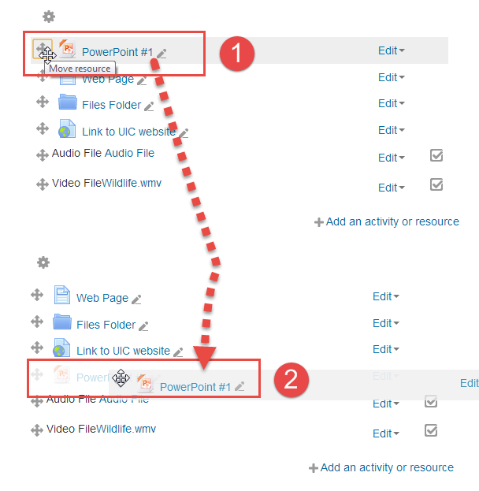

*NOTE: You can also drag and drop entire Topic to move the whole section*.

* 1. **Organizing Items within a Section through Labels.**

Labels can help you to organize resources and activities within a section, you can add labels, like ‘Before You Start the Course: Do These Readings’, for giving a direct to your students.

Follow the steps below to add a Label to one or more of the sections on the course home page.

1. Click Turn editing on at the top right of the course main page.



1. Click ‘Add an activity or resource’ in the course section where you want the label to be added.



1. Select ‘Label’ in the pop-up under Resources, and then click Add button.

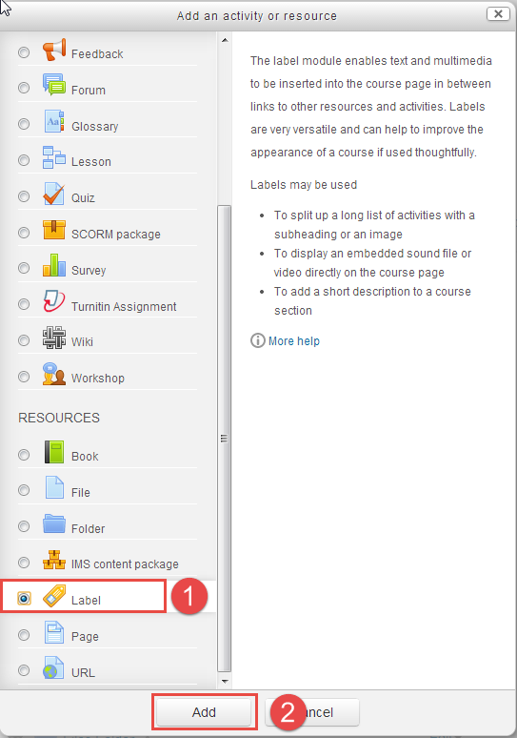

1. Enter the text for the label that will be presented on the main course page.

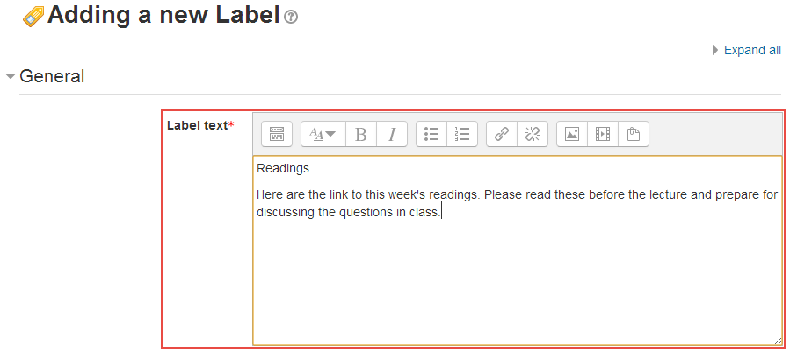

1. Click ‘Save changes’ button to save your work, and then return to the course homepage.

**Part 4 Assessment & Evaluation**

1. **Assignment**

The assignment activity module enables a teacher to communicate tasks, collect work and provide grades and feedback.

Students can submit any digital content (files), such as

* Word-processed documents
* Spreadsheets
* Images, Audio and Video clips
* Online text
  1. **Adding** **Assignment**

Follow the steps below to add an assignment to one or more of the sections on the course home page.

1. Click Turn editing on at the top right of the course main page.



1. Click ‘Add an activity or resource’ in the course section where you want the label to be added.



1. Select ‘Assignment’ in the pop-up under Resources, and then click ‘Add’ button.

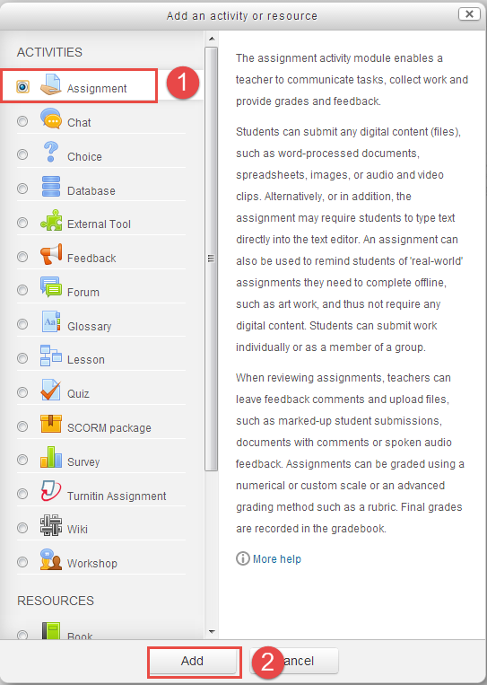

* 1. **Configuring Assignment**
* **General**
  1. Enter Assignment name which will appear as a link to access the Assignment on the course main page.
  2. Enter a brief description about the assignment. If ‘Display description on the course page’ is checked, the description will be displayed on the course page just below the link to the assignment.

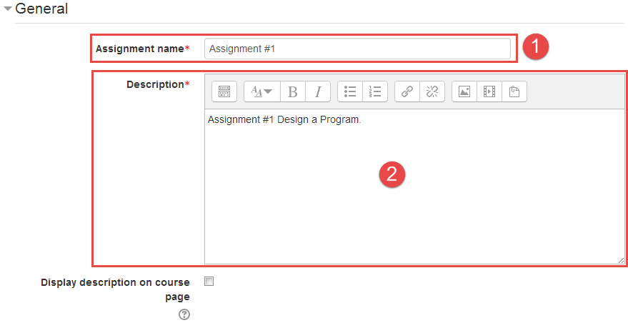

* **Availability**
  1. Select the submission start date and time in the ‘Allow submissions’ dropdown lists,.
  2. Select the assignment due date and time, after this date, submissions will still be allowing, but will be marked as late.
  3. In the ‘Cut-off date’ dropdown lists, select the date and time, after this date, any assignment will not be accepted.

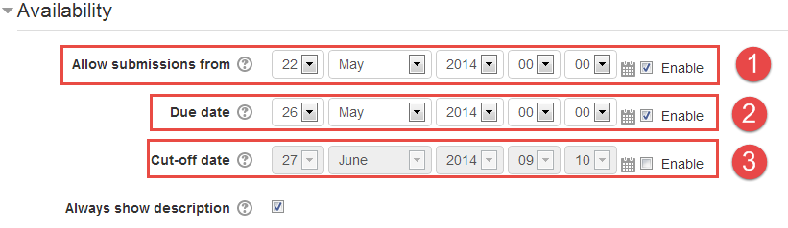

* **Submission types**
  1. In the ‘Submission types’ checkbox group, choose the appropriate submission type:
* **Online text** allows students to type rich text into an editor field for their submission.
* **File submissions** allows students to upload one or more files as their submission.
  1. If ‘File submissions’ checkbox is checked, the number of upload files will be limited by this maximum number which you selected.
  2. Select an appropriate size limit for each uploaded file.

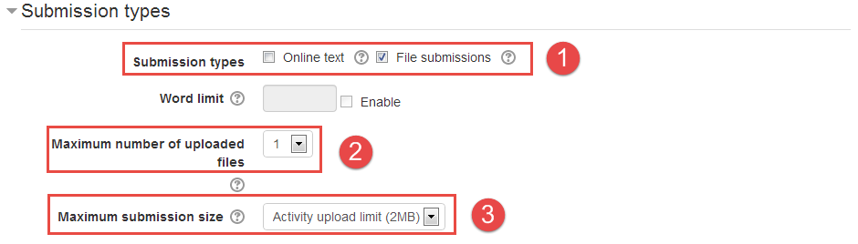

* **Feedback Types**

Select the preferred Feedback types to provide feedback to student.

* **Feedback comments** allows marker to leave text comments for each student.
* **Feedback files** allows marker to upload files (word document, audio, etc.) with feedback to each student.
* **Offline grading sheet** allows markers to download and upload a worksheet with student grades.

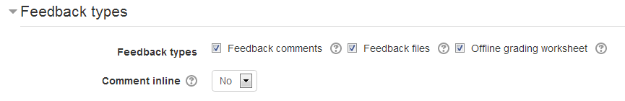

* **The Rest of Option**

Configuring the rest of option as your need, click the question mark () for help, the description of this option will be presented in a popup window.



Click ‘Save and display’ button to view the assignment.

* 1. **Grading Assignments**

When you add an assignment to your course, a corresponding grade column is automatically added to iSpace Gradebook. Also when an assignment is graded, the grade will be appeared in this column automatically.

There are two ways to grade submissions: 1. Online grading, 2.Offline grading.

* **Online Grading**

Follow these steps to grade assignment submissions online.

1. Click the name of the assignment on you course main page.

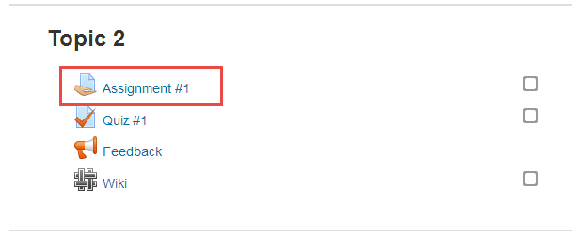

1. Click the ‘View/grade all submissions’ link below the ‘Grading summary’ table.

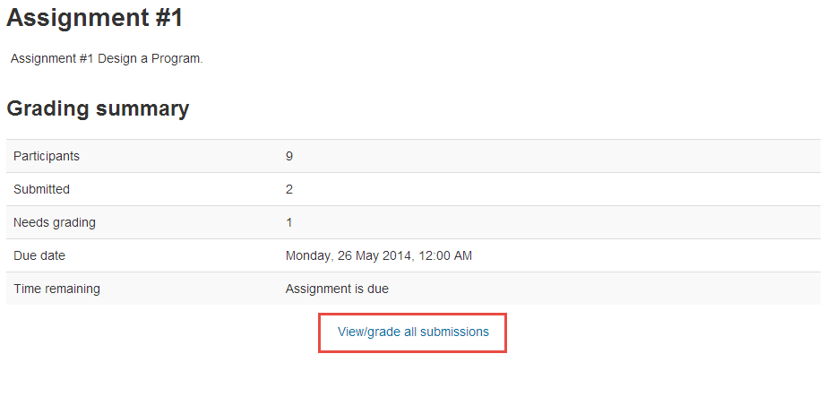

1. Click the grade icon () in ‘Grade’ column to view submission details.

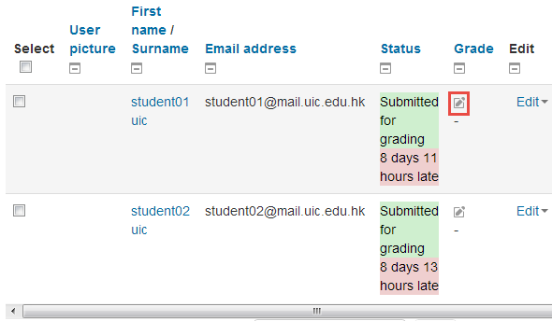

1. View the submission status, and click the file link in file submissions row to download the file.

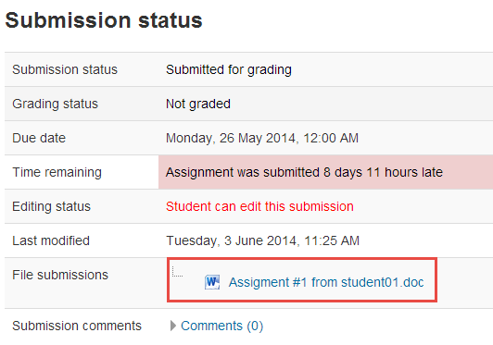

1. Enter grade and provide feedback comments to students, the ‘feedback file’ option exists whether depends on your feedback setting.

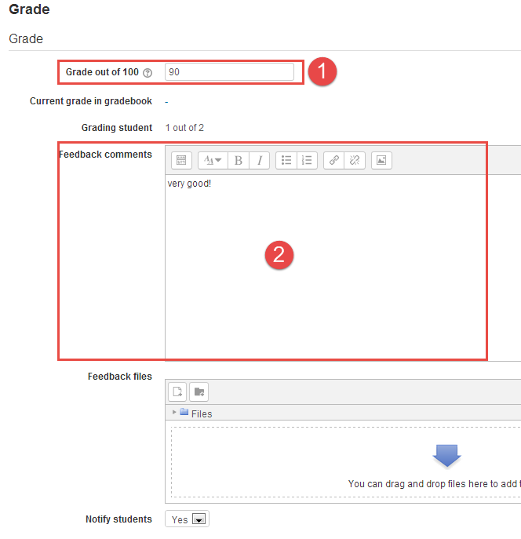

1. Click the ‘Save and show next’ button to save changes and display the next submission.

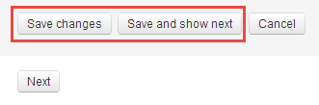

* **Offline Grading**

You may want to grade submissions in offline situation, like no internet satiation.

First, you should enable the ‘Offline grading worksheet’ option within the ‘Feedback Type’ part in the Assignment settings.

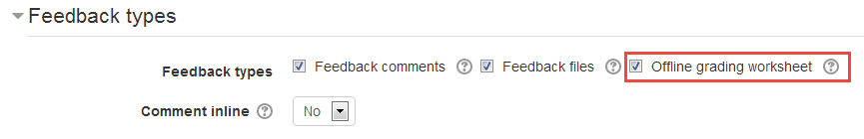

Then you can download all submission and an offline worksheet to grade assignment submissions outside of iSpace or Internet.

Follow these steps to grade offline.

1. Click the name of the assignment on you course main page.



1. Click the ‘View/grade all submissions’ link below the ‘Grading summary’ table.



1. Choose ‘Download all submission’ from grading action dropdown menu to download all submission to your computer as a zipped file.

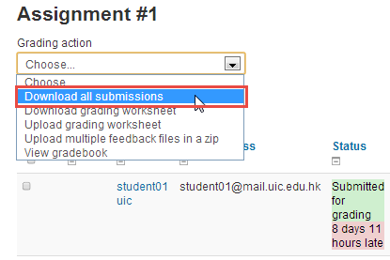

1. Choose ‘Download grading worksheet’ from grading action dropdown menu to download grading worksheet to your computer.

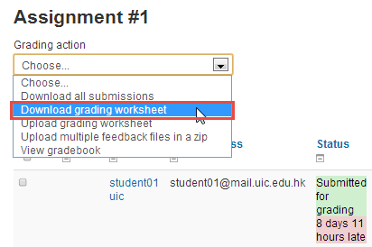

1. After view students’ submission on your computer, fill the grading worksheet.

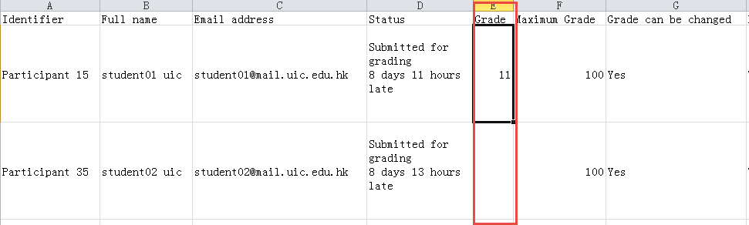

1. Choose ‘upload grading worksheet’ from the ‘Grading action’ dropdown menu.

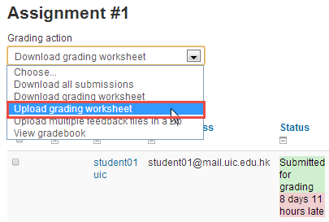

1. Upload the grading worksheet.

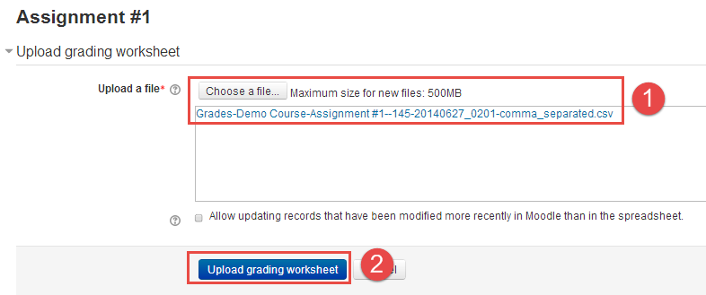

1. Click the ‘Confirm’ button to confirm the changes

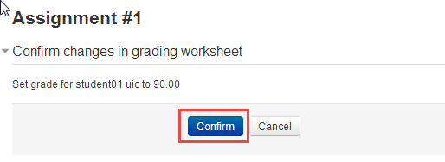

1. **Quiz**

The Quiz activity allows the teacher to design and build quizzes consisting of a large variety of Question types, including multiple choices, true-false and short answer questions. These questions are kept in the Question bank and can be re-used in different quizzes, thereby reducing quiz development time as well as avoiding question duplication.

Quizzes can be configured to allow multiple attempts. Each attempt at a question is automatically marked, and the teacher can choose whether to give feedback and/or show the correct answers.

2. 1. **Adding a Quiz**
3. Click Turn editing on at the top right of the course main page.



1. Click ‘Add an activity or resource’ in the course section where you want the label to be added.



1. Select ‘Quiz’ in the pop-up under Activities, and then click ‘Add’ button.

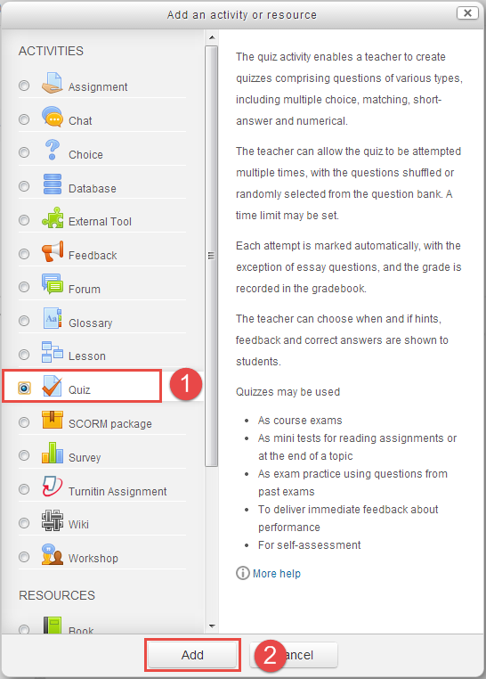

* 1. **Configuring Quiz**

Click ‘Expand all’ to expand each of the sections.

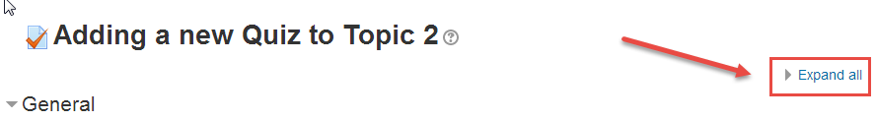

* **General**

Enter quiz name and description, click the ‘Display description on course page’ if you would like to display it on course main page.

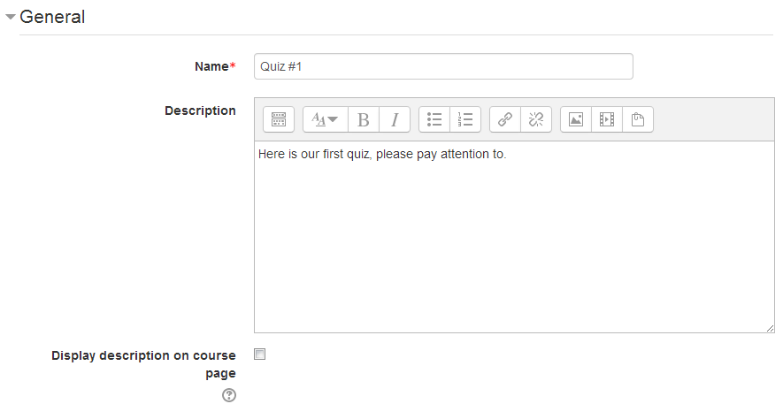

* **Timing**

1. Select date and time for opening the quiz at specific date and time.
2. Select date and time for preventing students from attempting the quiz after this certain time.
3. Enter the number of time which student must complete the quiz within.
4. Select a behavior which you need when the time limit is up.
5. If you select ‘There is a grace period…’ ,then you can enable the ‘Submission grace period’ and specify a period of time.

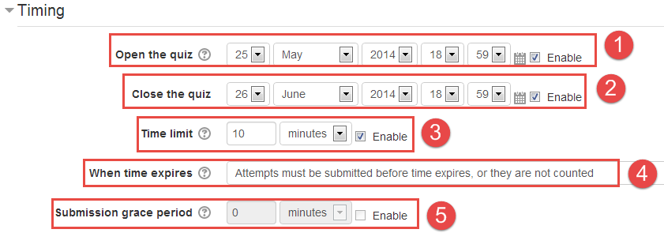

* **Grade**

1. Select the number of times a student can attempt the quiz.
2. Select a grading method which is used to calculate the student’s final grade for the quiz when multiple attempts are allowed.

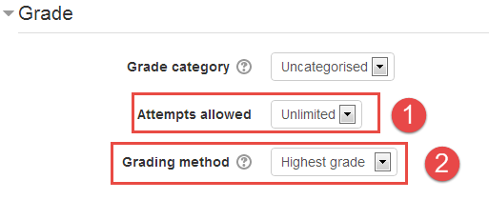

* **Layout**

1. Select ‘Shuffled randomly’ if you would like to shuffle questions each time a student attempts.
2. Select the number of questions that present per page.

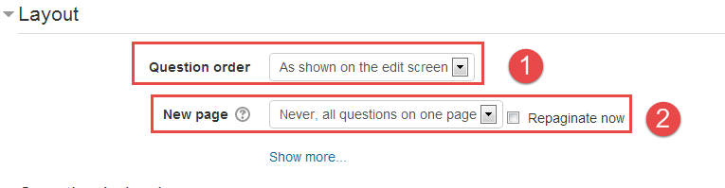

* **The rest of option**

Configuring the rest of option as your need, click the question mark () for help, the description of this option will be presented in a popup window.



* 1. **Adding and organizing Questions**

After Create a Quiz in your course, the next step is adding questions to the quiz. There are three ways to add question to a quiz:

1. Adding questions by creating new questions.
2. Adding questions from a category of question bank.
3. Adding random questions from a category of question bank.

**Adding questions by creating new questions.**

1. Click the Quiz on the course main page.

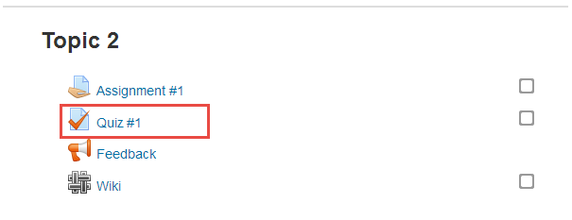

1. Click the ‘Edit Quiz’ in Administration block.

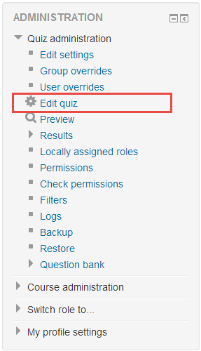

1. Click the ‘Add a question’ button.

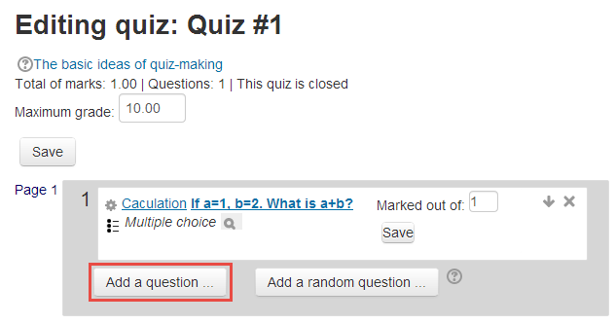

1. Select the desired question type and click ‘next’ button in a pop window.

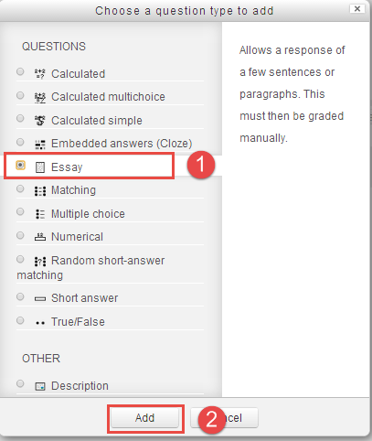

1. Fill the question form, and make sure that you give a grade to the correct answer.

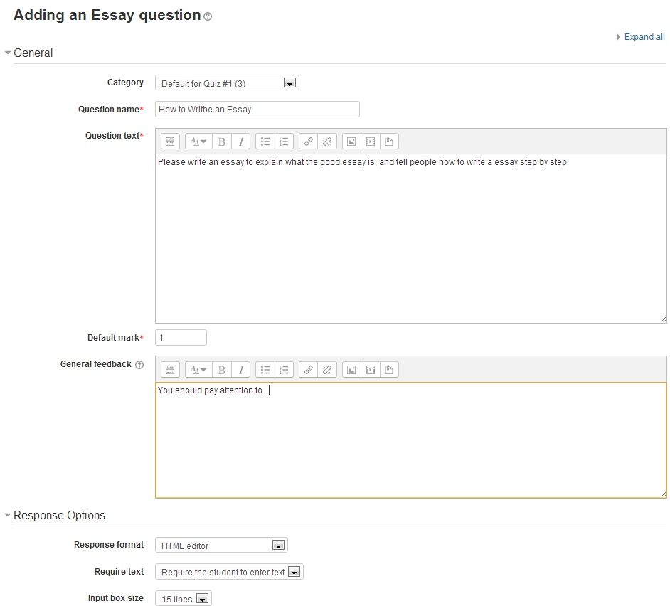

1. Click ‘Save changes’ and a question have been created.

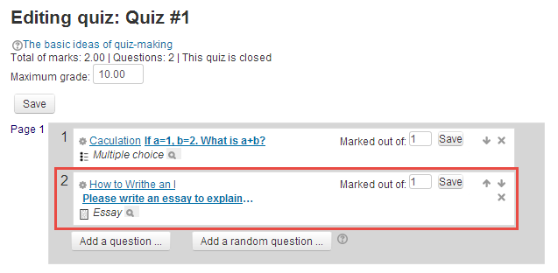

**Adding questions from a category of question bank.**

1. Click the Quiz on the course main page.



1. Click the ‘Edit Quiz’ in Administration block.



1. Adding questions to the quiz by question bank in the left of the page. Please follow these steps.
2. Select the category from ‘Select a category’ dropdown lists
3. Tick the checkbox of the question you would like to add to the quiz.
4. Click the ‘Add to quiz’ button to add those question to the quiz.

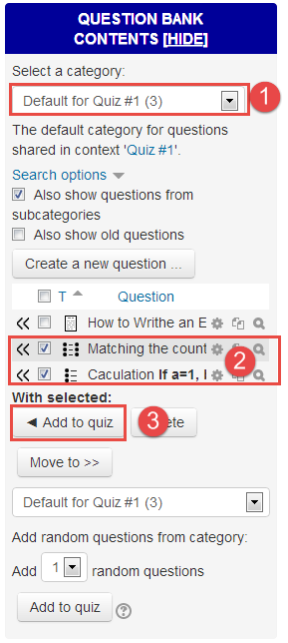

**Adding Random questions from a category of question bank.**

By adding random questions, when you have students in a class taking a quiz at the same time, they are unlikely to get the same questions at the same time. Please follow these steps.

1. Select the category from ‘Select a category’ dropdown lists.
2. Select the number of questions, and then click the ‘Add to quiz’ button.

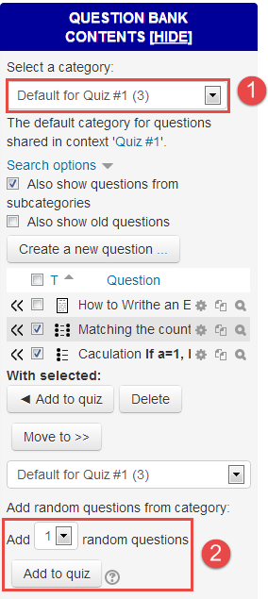

* 1. **Preview Quiz**

You can preview the quiz before releasing it to student.

Click the ‘Preview’ link in ‘Quiz administration’ block.

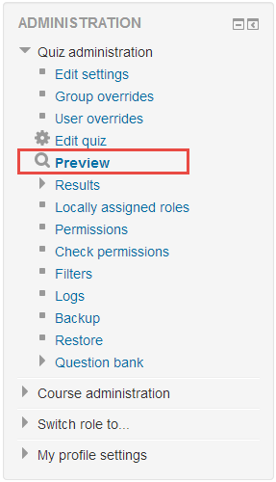

* 1. **Review and grade attempts**

1. Click the Quiz on the course main page.



1. Click the ‘Attempts’ link to view student attempts.

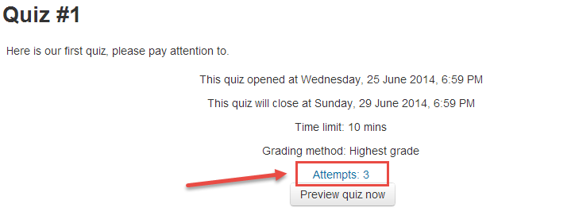

1. Click the ‘Review attempt’ link below students’ name to view the attempt.

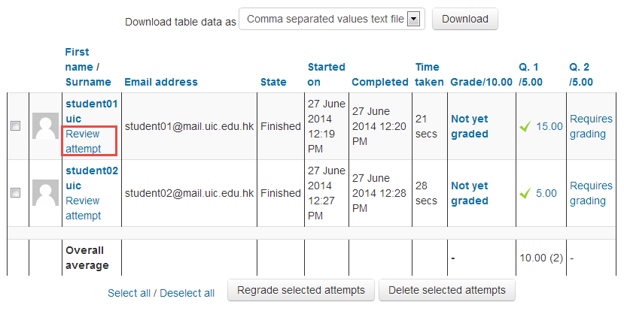

1. Click ‘Make comment or override mark’ to manually grade the question.

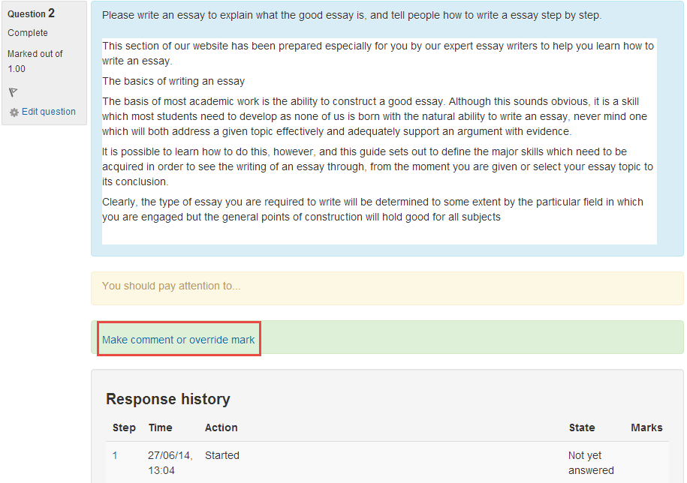

1. Enter feedback in comment text box and enter grade in mark field.

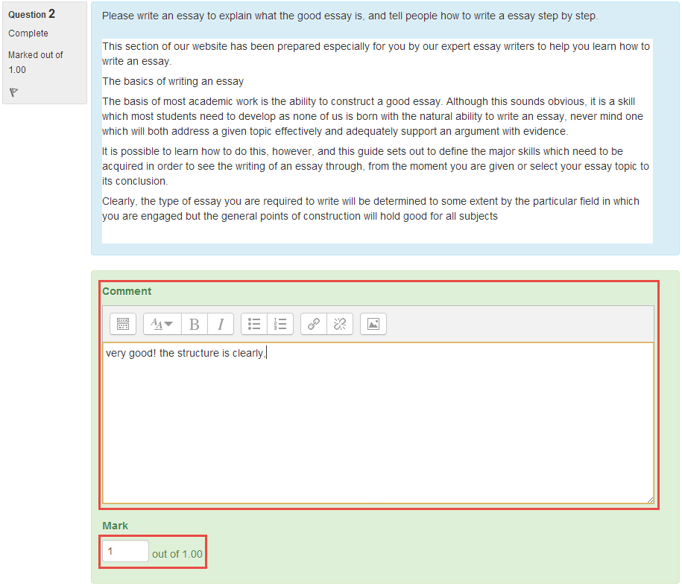

1. Click the ‘Save’ button.
2. **Feedback**
3. 1. **Adding a Feedback to your Course**
4. Click ‘Turn editing on’ button at the top right of the course main page.



1. Click ‘Add an activity or resource’ in the course section where you want the label to be added.



1. Select ‘Feedback’ in the pop-up under Activities, and then click ‘Add’ button.

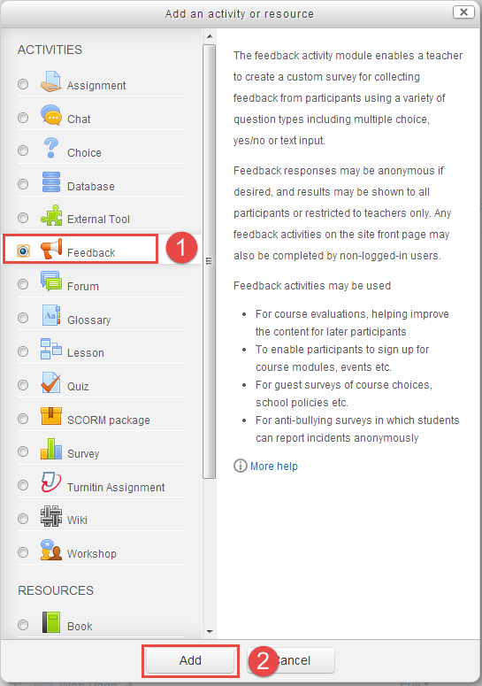

* 1. **Configuring Feedback Activity**
* **General**

Enter quiz name and description, click the ‘Display description on course page’ if you would like to display it on course main page.

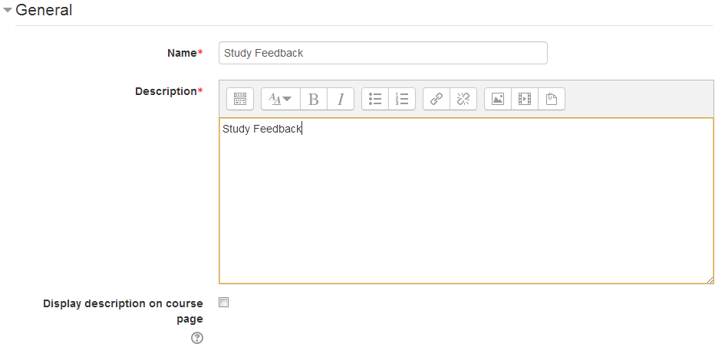

* **Availability**

If you would like to enable availability limits, please tick the ‘enable’ checkbox first. Then select date(s) and time(s) to make the feedback available from the ‘Allow answers from’ date to the ‘Allow answers to’ date.

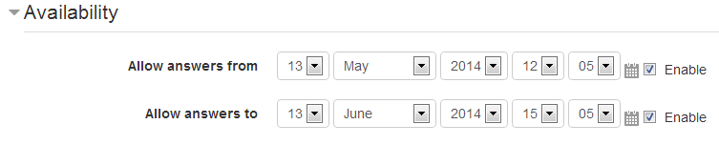

* **Question and submission settings**

1. Select ‘Anonymous’ if you want to hide the users’ names, or select ‘Users’ name will be logged and shown with answers’ to display user’s name with result.
2. Select ‘Yes’ will allow users to take the feedback multiple times, if you select ‘Anonymous’ in ‘Record user names’ option above, every submission will be recorded, if you select ‘Users’ name will be logged and shown with answers’ , only the most recent submission will be recorded; select ‘No’ will limits users to submit once.
3. Select ‘Yes’ if you would like to receive a E-mail each time a user submit a feedback.
4. If you Select ‘Yes’, then the question will be automatically numbered.

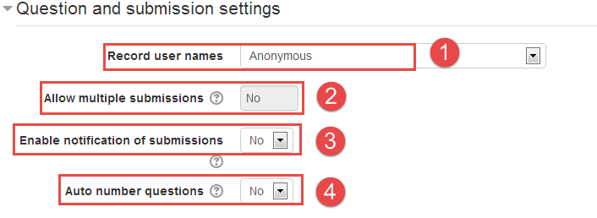

* **After Submission**

1. Select ‘Yes’ if you would like to show the summary result to respondents.
2. ‘Completion message’ allow you present users with a message after they submitted the feedback.

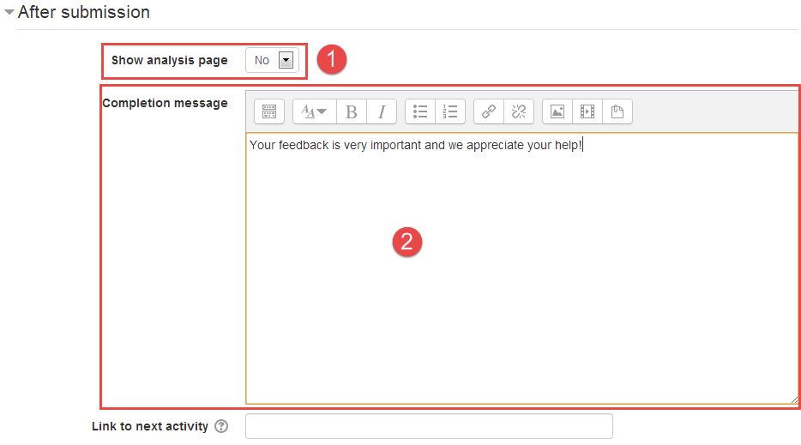

* 1. **Adding Questions to the Feedback**

1. Click the ‘Edit questions’ tab on the top, and then select the question type you want to add.

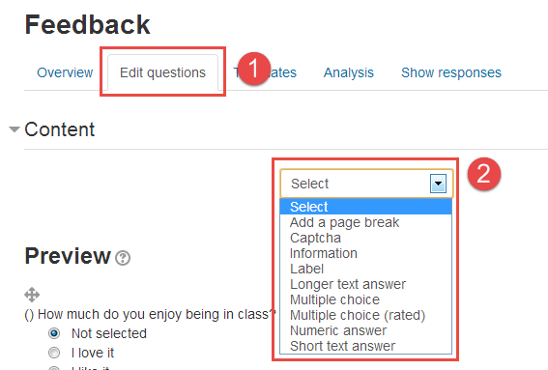

**The description of available options:**

|  |  |
| --- | --- |
| Add a page break | This option will put the following question on a new page. |
| Captcha | Asks a person to write out some distorted text which is displayed on screen. You normally won't need this unless you find you are getting spammed a lot. |
| Information | This allows you to choose to display one of three types of information: the time of responding; the course and/ or the category where the feedback is located. |
| Label | This allows you to add text between questions allowing for extra explanation or to divide the Feedback into sections. |
| Longer text answer | This is for creating a text box (you specify how big it will appear in rows and columns) which people can write a long answer into. |
| Multiple choose | This will give you a series of options with a checkbox next to each one. It can be defined as multiple answers, single answers or dropdown list style. |
| Multiple choice (rated) | Each answer is associated with a number. This allows you to calculate averages and perform other calculations with the data that you collect. |
| Numeric answer | This helps if you specify the acceptable range in the question text. For example: from 0-10. |
| Short text answer | This option lets you specify a single line answer, with an input box which is a set number of characters long (you choose). |

1. Configure the question as desired, and click ‘save changes to question’/’Save as new question’ button.

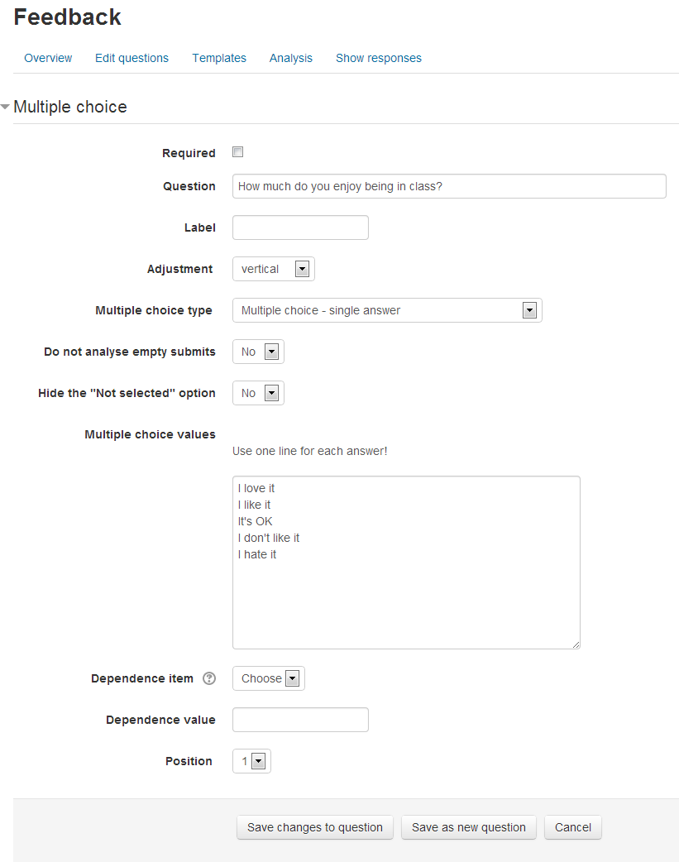

* 1. **Analyzing and Exporting Feedback Results**

1. Click the name of the Feedback activity from the course main page.

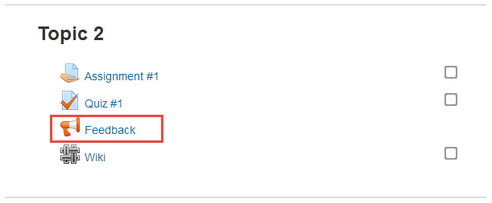

1. Click the ‘Analysis’ tab to view the percentages of each choice and text feedback.

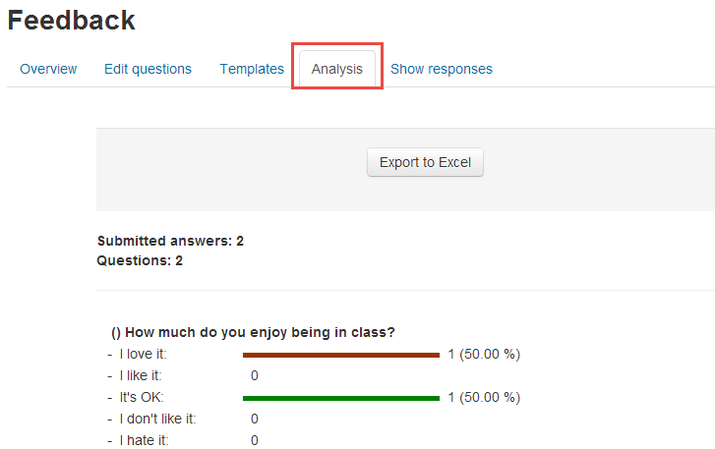

1. Click the ‘Exprot to Excel’ to export the result to an Excel spreadsheet.

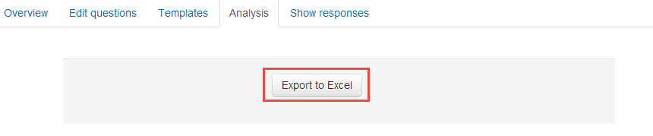

1. **Gradebook**
   1. **View and editing grades.**
2. Click the ‘Grades’ link in the ‘Administration Block’.

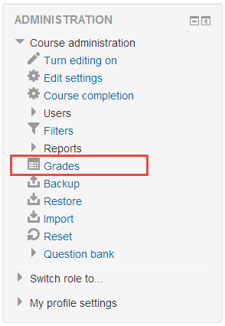

1. View the students’ grades.

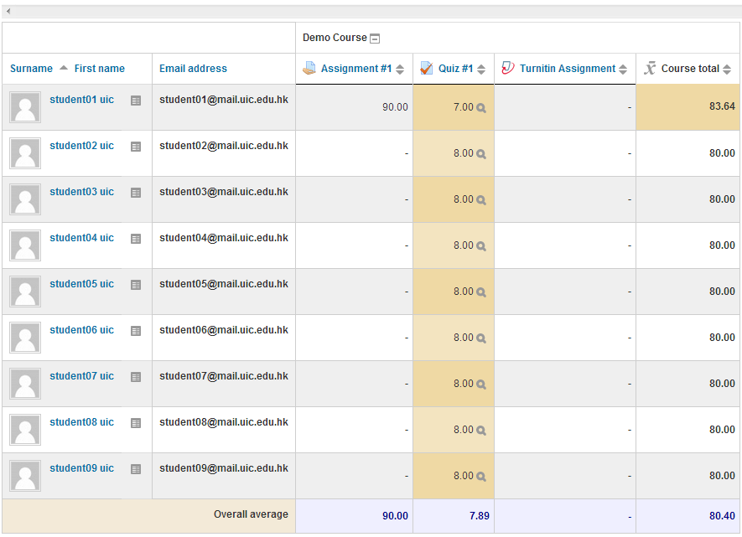

1. Click the ‘Turn editing on’ button at the top right of the page.



1. Edit the grades in the input field; the grades will be saved automatically.

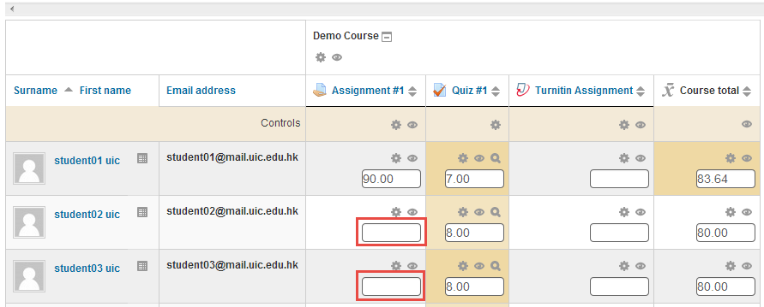

* 1. **Export and import grades.**
* **Export**

1. Click "Export" tab.



1. Click "Excel spreadsheet".

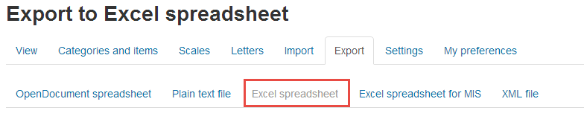

1. Select items you would like to include in the excel spreadsheet, and then click ‘submit’ button.

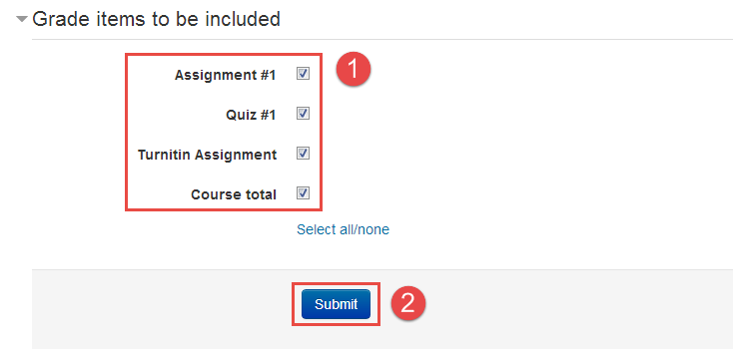

1. Click "Download" and save the excel file.

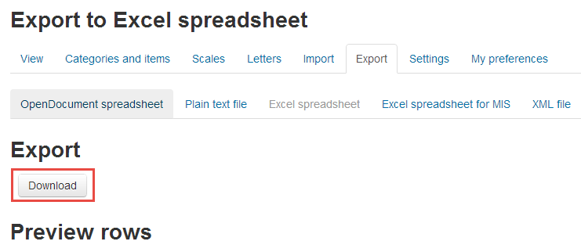

* **Import**

1. Open the excel spreadsheet which you can get from ‘export grades’, edit the grades.

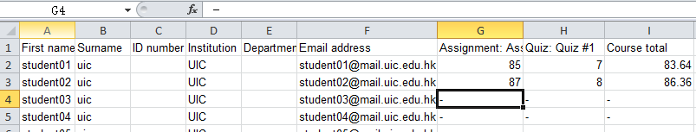

1. Select ‘Save as type’ as ‘CSV’ format, and click ‘Save’ button.

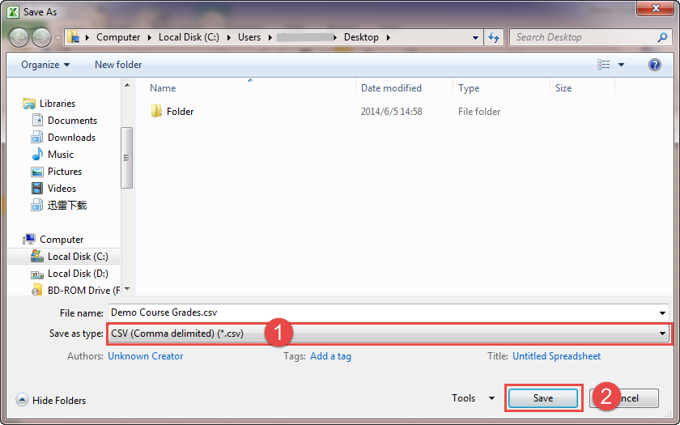

1. Click ‘Import’ tab, and then click ‘CSV’ in ‘Grades’ administration.

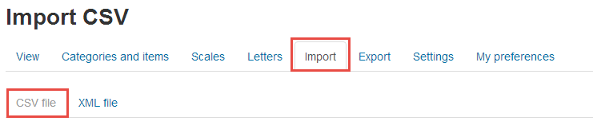

1. Click ‘Choose a file’ to upload the CSV file or drag and drop the CSV file to file area to add them, and then click ‘upload grade’.

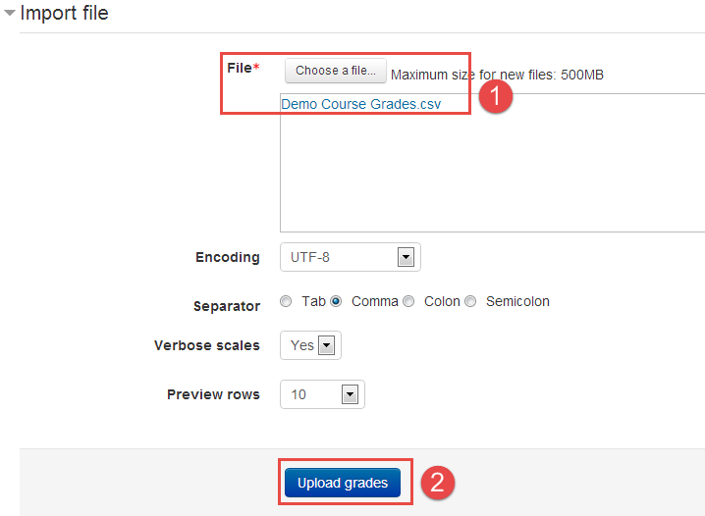

1. Mapping data and upload grades. Please follow these steps below.
2. Select ‘Email address’ from ‘Map from/Map to’ dropdown lists to identify user by Email address.
3. Mapping the grades you want to upload.
4. Click ‘upload grades’ button, and then ‘Grade import success’ will be presented.

